MINI PROJECT
FASHION RETAIL SALES PERFORMANCE AND CUSTOMER INSIGHTS

BATCH - ML-DAF-69
NAME - MOHAMMED FAZIL

Project Summary
Fashion Retail Sales Performance and Customer Insights analyses the sales transactions, product information, customer characteristics and store performance. This project covers 50,000 transactions from January 2020 to December 2024. Microsoft Excel was used to inspect, clean and prepare the data, handle missing values and create calculated fields. Power BI was used to connect the tables, calculate performance indicators and build three interactive pages: Sales Overview, Products & Stores, and Customer Insights.
The main aims of this project are to understand the revenue trends, estimated profitability, returns and purchasing patterns. The financial values presented in this project are estimated based on reference prices and reasonable assumptions used for the hypothetical business case.

Raw Dataset Source and Description
The original dataset website link is given below - Fashion Retail Sales Performance and Customer Insights
These project uses above mentioned dataset which contains 4 CSV files. All the records details are given below. All the files have a relationship through Product ID, Customer ID and Store ID.

Raw file | Records | Columns | Main information
sales_data.csv | 50,000 | 8 | Transactions, dates, IDs, quantities, discounts and returns
product_data.csv | 50,000 | 8 | Categories, colours, sizes, seasons, suppliers, costs and list prices
customer_data.csv | 25,000 | 5 | Customer IDs, ages, genders, cities and emails
store_data.csv | 5 | 4 | Store IDs, names, regions and sizes

Project scope and requirements
The project covers the preparation and descriptive analysis of 50,000 fashion retail transactions from 2020 to 2024, using Microsoft Excel and Power BI. It shows with the data, how sales change over time, which product categories and stores contribute most, and how purchasing activity shows differences across customer groups.
These financial results are estimates based on the available product prices and reasonable assumptions made for unknown or missing values in the dataset. For presentation purposes, the US Dollar has been used as the currency for selected financial columns in this hypothetical retail case study.

Contents | Project scope
Data preparation | Clean and process Sales, Products, Customers and Stores data in Excel through duplicate checks, missing-value treatment, standardization, lookups and validation.
Financial calculations | Create estimated revenue, cost and gross profit fields, considering quantities, discounts and return status.
Sales performance | Analyze monthly and yearly trends, transaction volumes, profitability and returns.
Product and store analysis | Compare sales and profitability across product categories, suppliers and stores.
Customer insights | Analyse purchasing activity across customer age groups, genders and cities.
Interactive reporting | Make a three Power BI pages—Sales Overview, Products & Stores, and Customer Insights—with performance indicators, filters, tooltips and navigation.
Business recommendations | To recommend suitable actions for pricing, promotions,  product selection, store performance, and return management.

Tools Used
The tools which are used and its purpose for this project is given below.
Tools or component Used | Purpose
Microsoft Excel | Data inspection, cleaning, formulas, lookups, conditional formatting and a yearly PivotTable
Power BI Desktop | Data modelling, relationships, interactive visuals and report design
Power Query within Power BI | Importing cleaned tables and reviewing data types and transformation steps
DAX within Power BI | Creating the Calendar table, measures and time comparisons

Data Cleaning & Processing
The workflow keeps the four business tables separate to maintain a clear data structure. Product costs and prices are added to the Sales table only when required for row-level calculations, while descriptive information remains in the original tables for use in Power BI relationships. The detailed records below explain the cleaning decisions and calculated fields used in the project. Where helper formulas were later replaced with values, the examples shown follow the same calculation logic.

Step | Activity | Method | Purpose
1 | Organise workbook | Separate Raw and Cleaned sheets. | Preserve source data.
2 | Create tables | Convert cleaned ranges to Excel tables. | Improve filtering and Power BI import.
3 | Check duplicates | Verify transaction and reference IDs. | Avoid duplicate records.
4 | Standardise formats | Set correct date, text, number, % and currency formats. | Ensure consistency.
5 | Standardise labels | Correct inconsistent category and supplier names. | Improve grouping.
6 | Handle missing values | Fill discounts, unknown customers and emails using defined rules. | Retain usable records.
7 | Apply imputation | Use suitable mode/median values where required. | Fill selected missing data.
8 | Add missing references | Create records for P999999 and S999. | Maintain table relationships.
9 | Retrieve prices | Use Product ID lookups for Unit_Cost and Unit_Price. | Support calculations.
10 | Create status fields | Add Return_Status and Revenue_Status. | Flag returns and incomplete rows.
11 | Calculate financials | Calculate estimated revenue, cost and gross profit. | Measure performance.
12 | Create Age_Group | Use nested IF formula. | Analyse customer segments.
13 | Check pricing | Add Price_Check. | Flag pricing issues.
14 | Validate data | Review formulas, formats and exceptions. | Improve data quality.
15 | Create PivotTable | Summarise yearly transactions, revenue and profit. | Validate Power BI totals.

- Step 1 — Preserve the raw data and create working tables
Separate Raw and Cleaned worksheets were maintained for Sales, Products, Customers and Stores. Each cleaned range was converted into an Excel table. Keeping the original records allowed changes to be checked. Fetching the data in the excel by clicking the get data and choose csv file. Renamed the raw and cleaned worksheet in differently
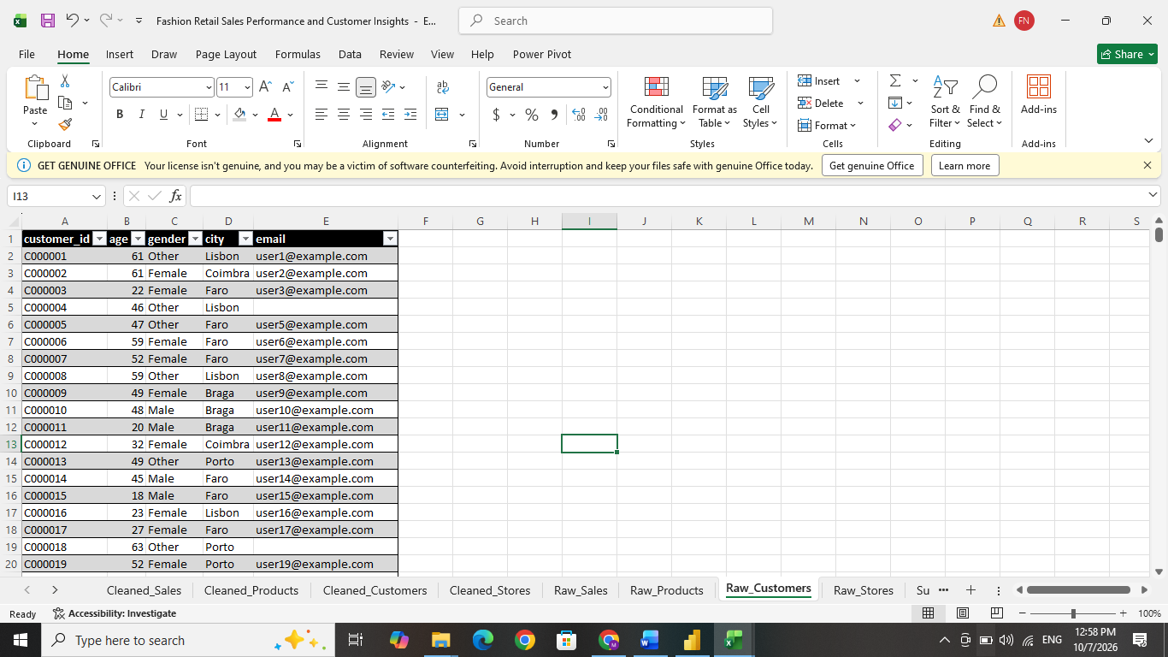
- Step 2 — Check duplicate records and cleared in all tables.
In all tables there was no duplicate values were found in the raw dataset. Select the dataset and go to data and click remove duplicates.

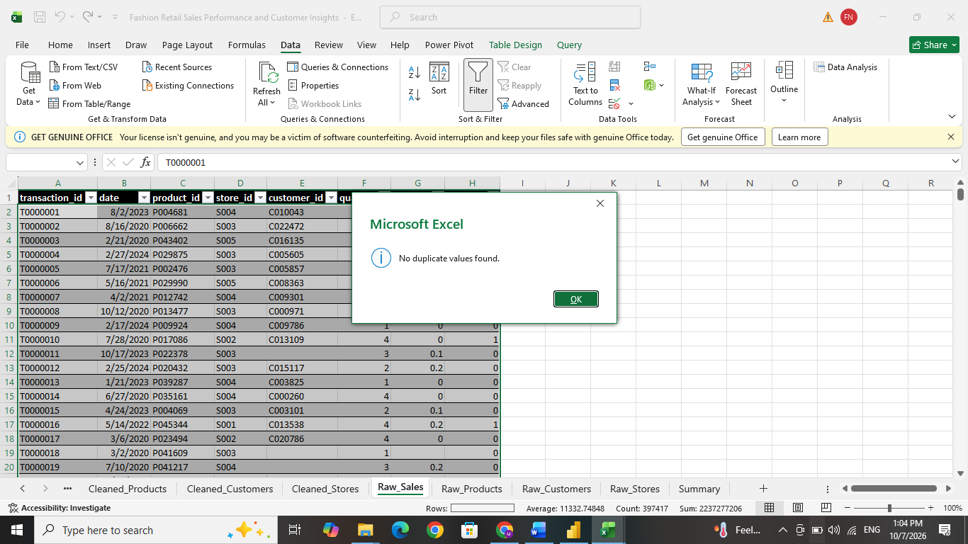

- Step 3 — Standardize formats and labels
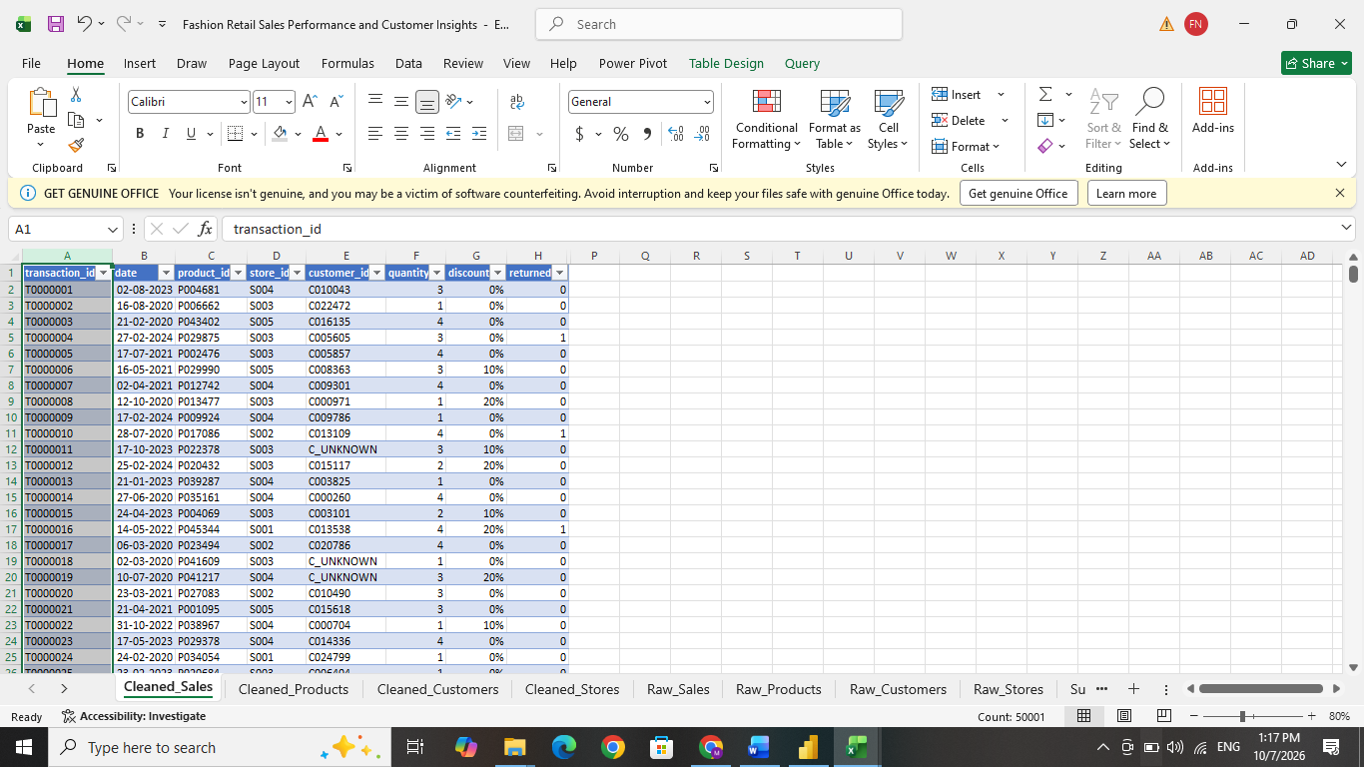
Transaction, Product, Customer and Store IDs are kept as text, preserving letters and leading zeros, such as P000001. These will maintain the original identifiers and support correct matching between tables. Select the column and go to home tab, in number section change the format to General.

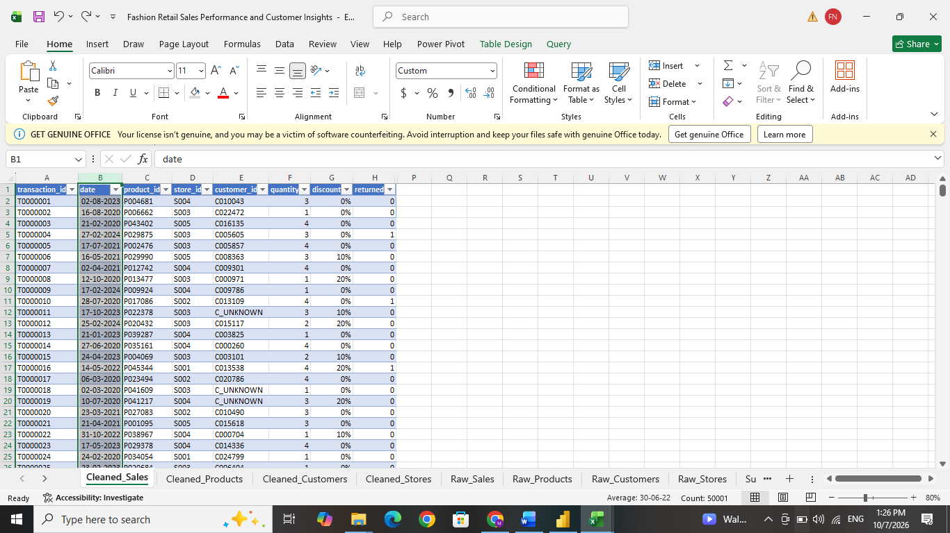
Next, the Date column was formatted to ensure consistency across all transaction records. The column data type was changed to Date, and the custom format dd-mm-yyyy was applied. This makes the transaction dates easier to read and helps maintain a consistent date format throughout the dataset. To apply the format, select the Date column, open Format Cells, choose the Custom category, and select or enter the format dd-mm-yyyy.

The Quantity, Age, Return Flag, and Store Size fields were checked and formatted as whole numbers with zero decimal places. Since these columns contain whole-number values, unnecessary decimal places were removed to make the data cleaner and easier to read. To apply the format, select the Date column, open Format Cells, choose the number format.
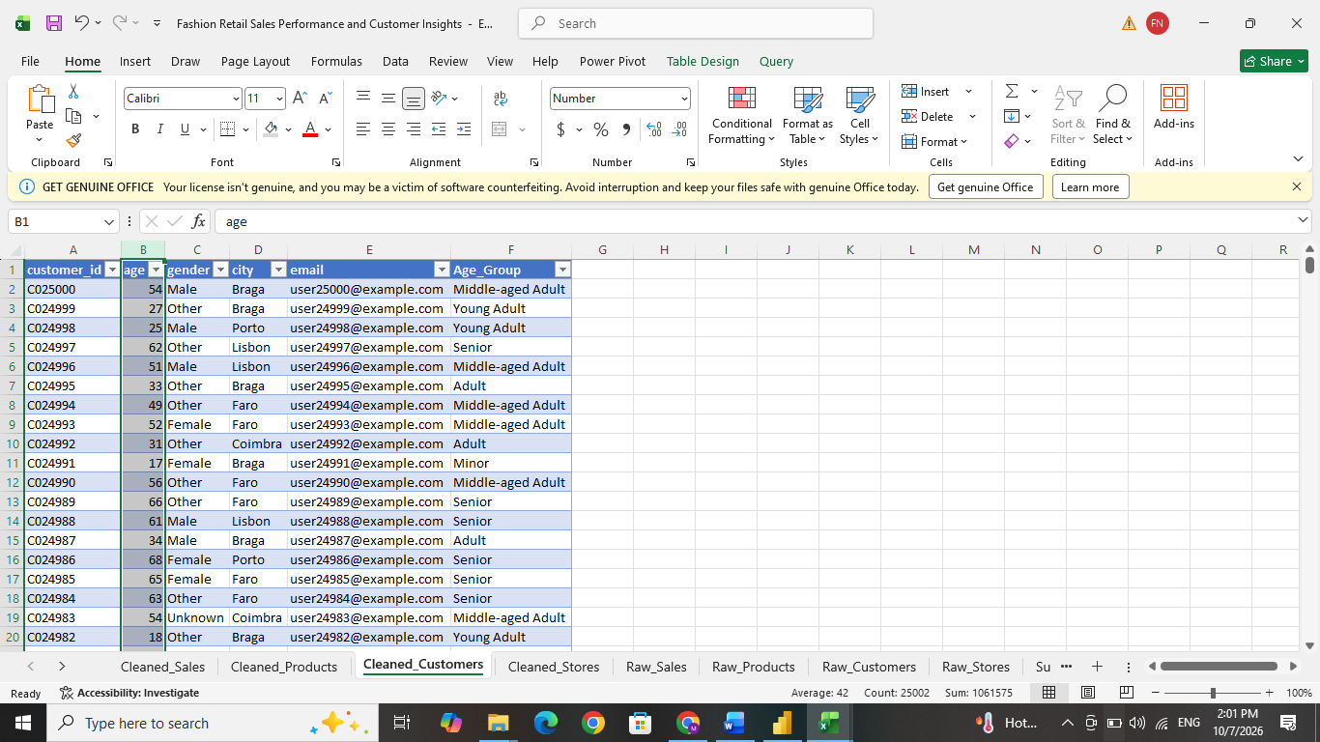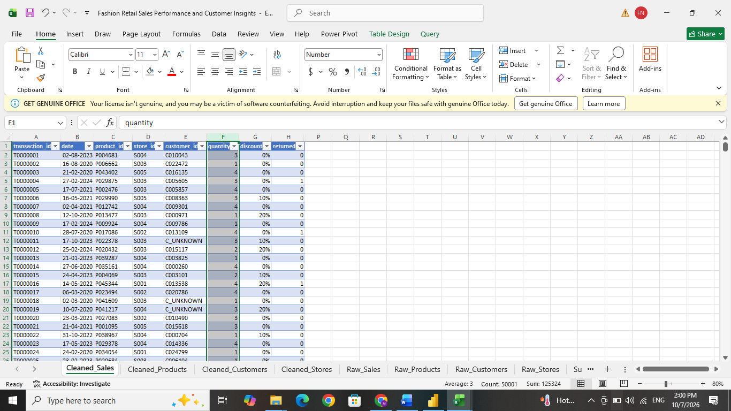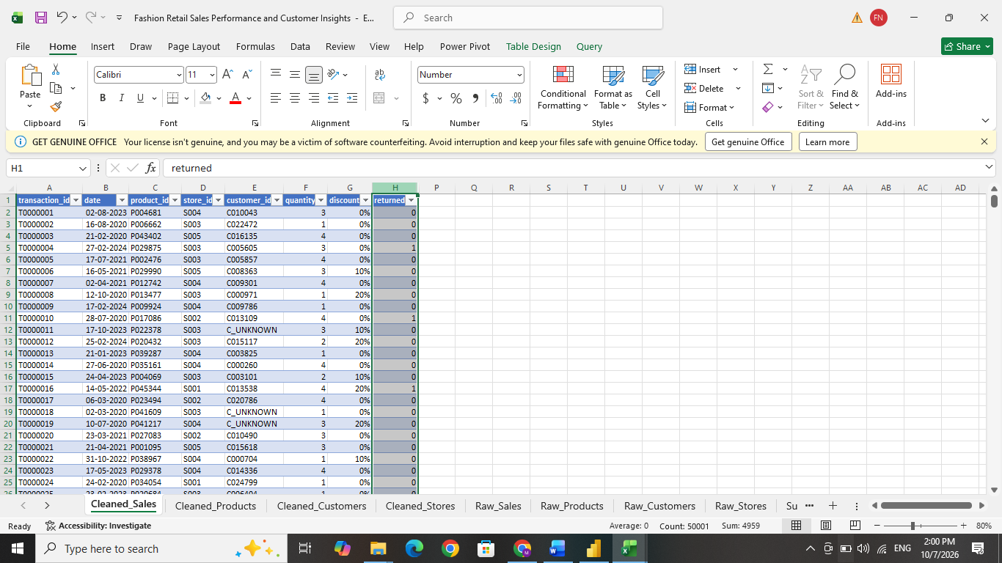

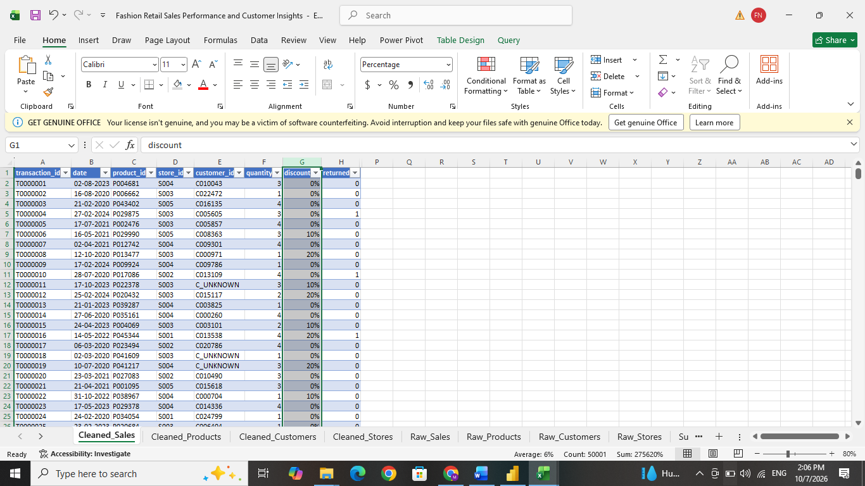
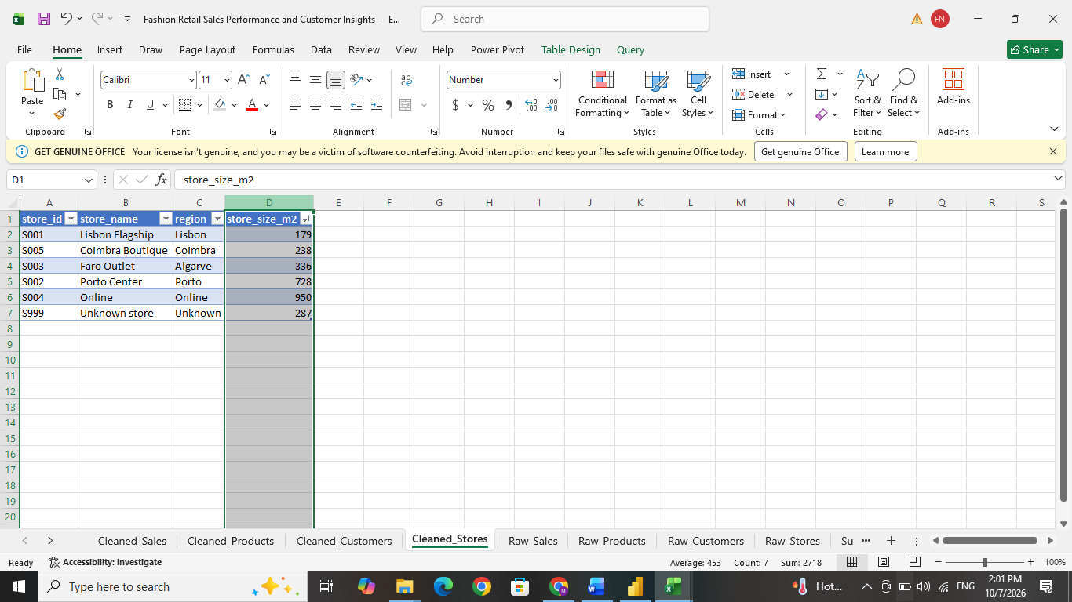
The Discount column was formatted as a percentage. Example - a numeric value of 0.10 is displayed as 10%. This makes the discount values easier to understand while keeping them in a numeric format for calculations and analysis. As same as above, select percentage format.

The Cost and List Price columns is formatted as Currency using the $ symbol with two decimal places. The same formatting will be applied to the calculated columns. This will give all money related values are presented consistently and that decimal values are kept where required.

The Supplier labels were standardized using Find and Replace. For example, suppliera was changed to Supplier A, and the same method was applied to the other supplier names. This makes the labels easier to read and keeps the naming consistent for grouping and reporting. To apply this, press Ctrl + F to open Find and Replace, enter the inconsistent supplier’s name, and replace it with the correct standardized format.
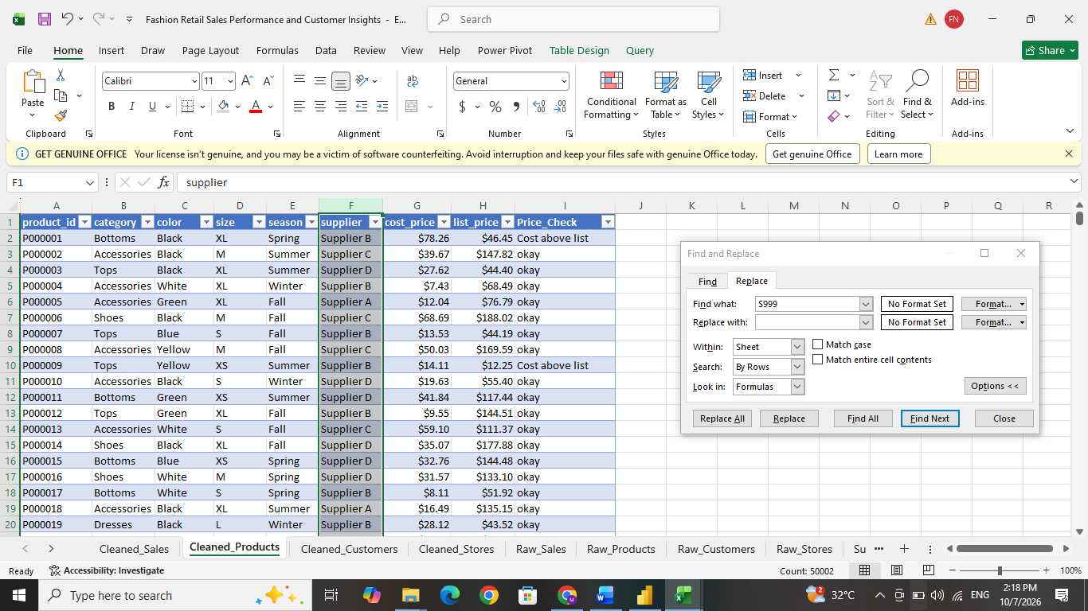
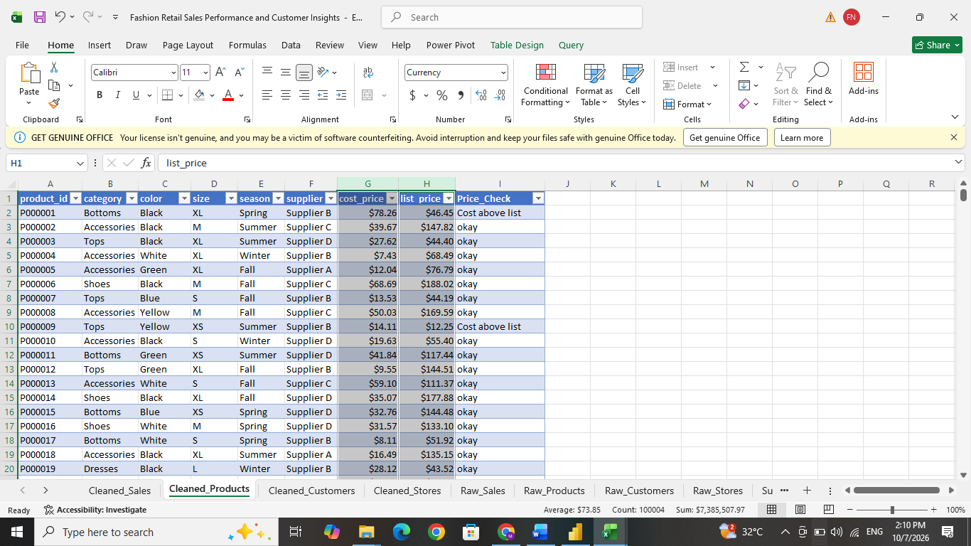

Step 4 — Handle missing discounts
The raw Sales table contained 2583 blank values in the Discount column. These missing values were replaced with numeric zero using the following formula:
=IF(G2="",0,G2)
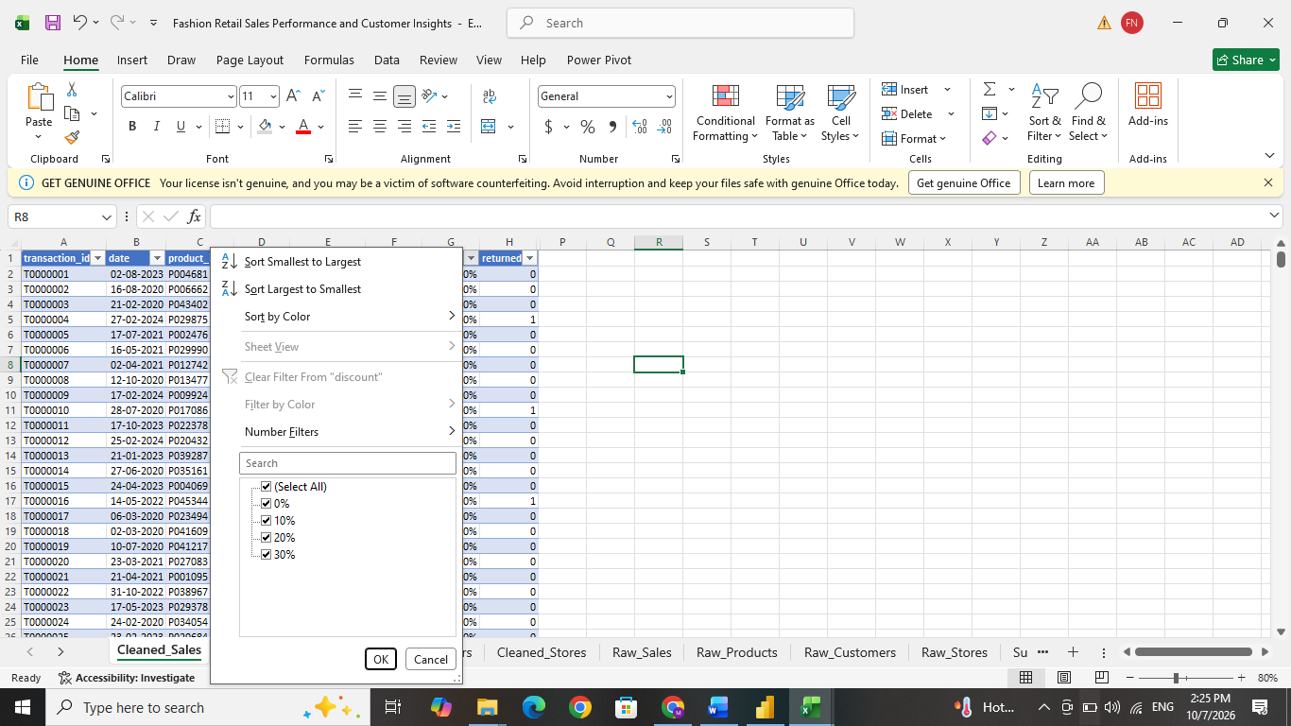
The formula checks whether the discount cell is blank. If it is blank, it returns 0; otherwise, it keeps the existing discount value. This step was required to calculate revenue consistently. For this project, blank discount values were assumed to represent no discount i.e. this is a project hypothetical assumption and may not always reflect the actual business situation.

Step 5 — Handle missing customer IDs
The Sales table contained 1844 blank Customer ID values. These missing values were replaced with C_UNKNOWN using the following formula:
=IF(E2="","C_UNKNOWN",E2)
The formula checks whether the Customer ID cell is blank. If it is blank, it returns C_UNKNOWN; otherwise, it keeps the existing Customer ID.
A corresponding C_UNKNOWN record was also added to the Customers table. This allowed transactions with unavailable customer information to remain in the dataset while maintaining the relationship between the Sales and Customers tables. C_UNKNOWN represents unidentified transactions and should not be treated or counted as an actual customer.

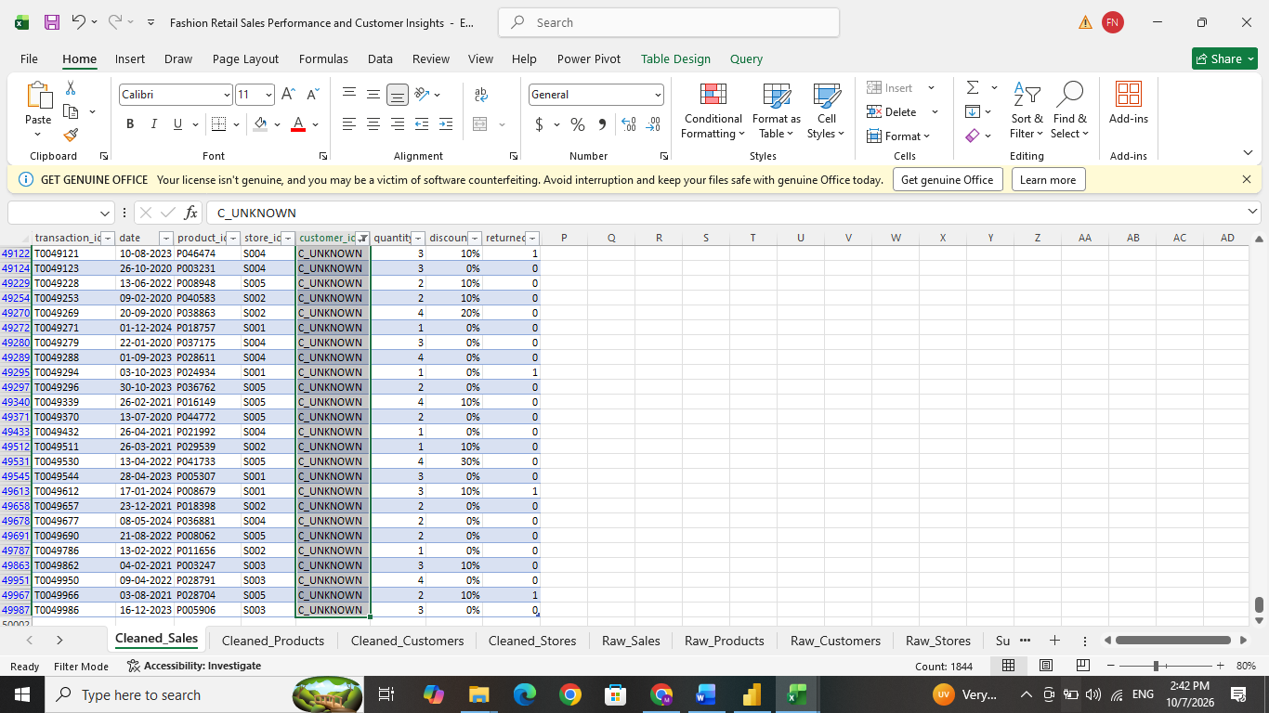

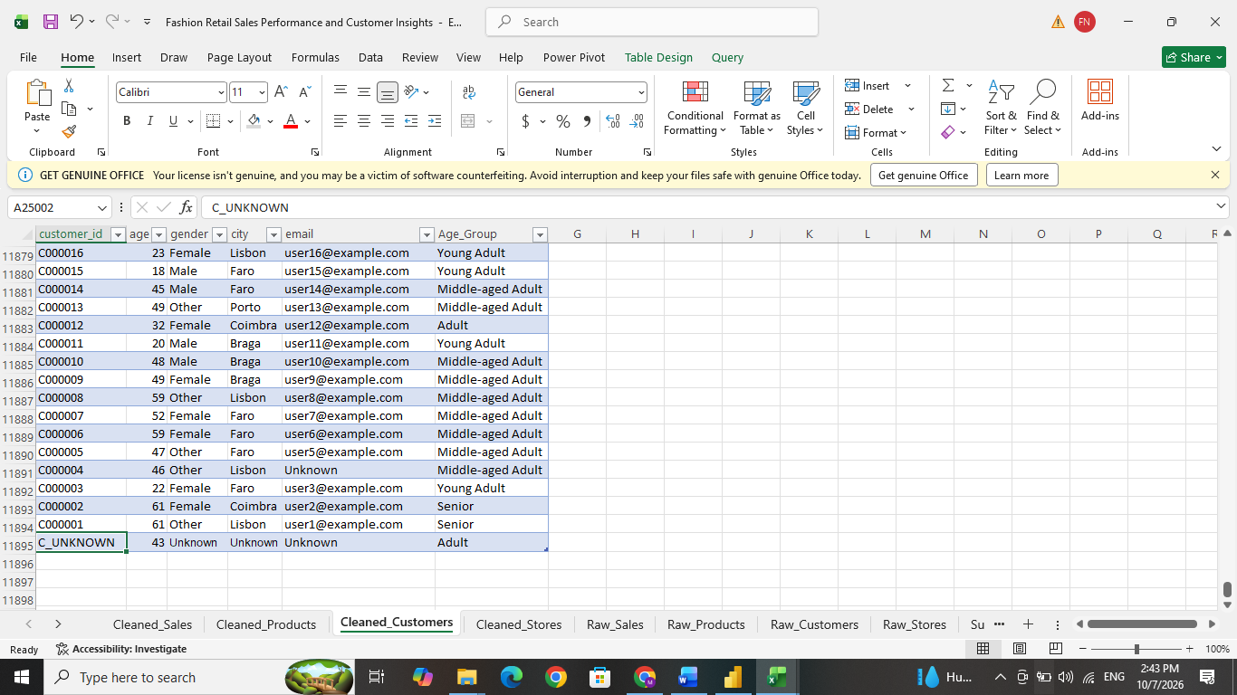

Step 6 — Handle unavailable gender and email values
In Gender column, 298 invalid gender entries were blank which is filled with mode imputation because it’s a categorial column. Male is most re occurring category so filled the empty cell with Male.
The formula used here is =IF(TRIM([@gender])="","Male",[@gender])
And also there is 496 blank emails were filled with Unknown. An email address cannot be estimated using mean, median or mode. Using Find and Replace we can fill these blanks spaces with unknown.

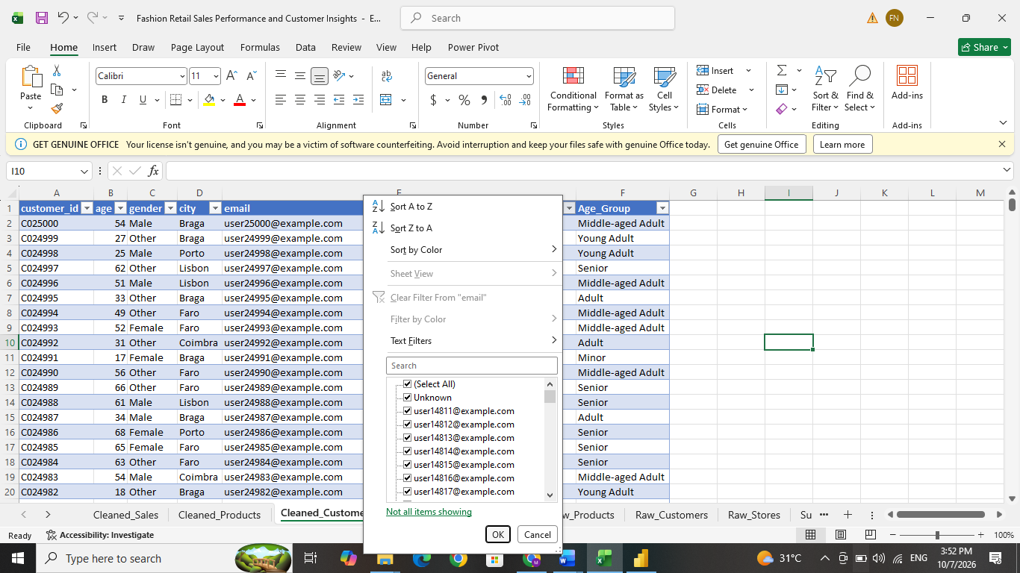

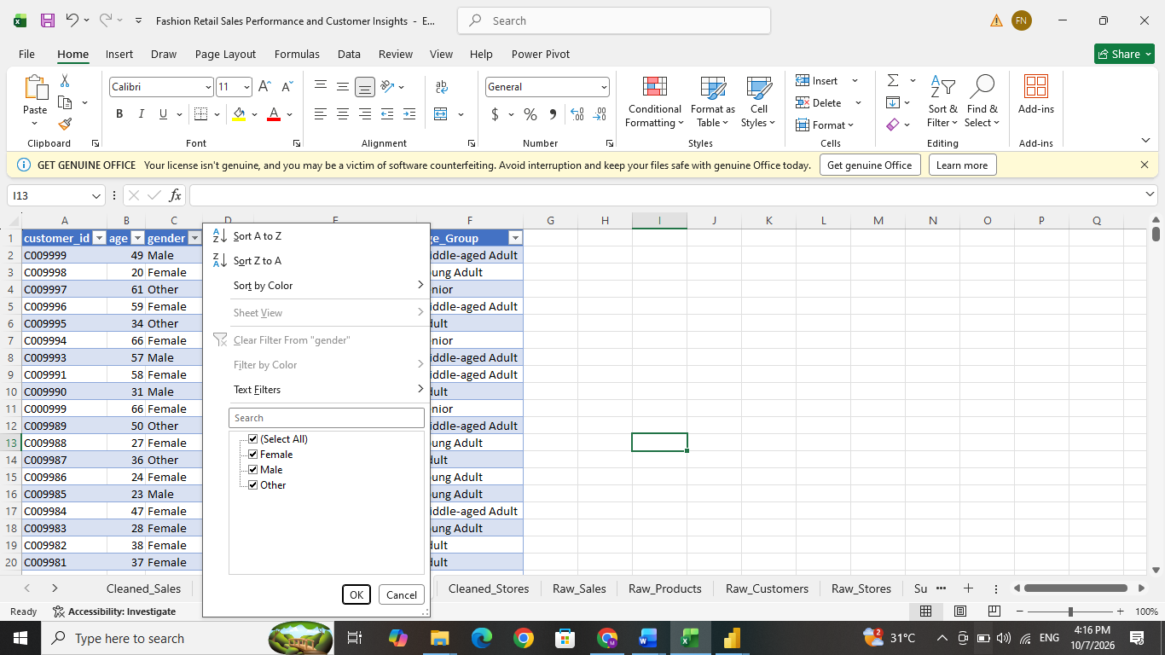

Step 6 — Handle unknown values and imputation in stores table.
In the Sales table, an unlisted Store ID- S999 was identified for transaction T0000072. Since this Store ID was not available in the Stores table, a new record was added to maintain the relationship between the Sales and Stores tables. The missing Store Size for this new store was filled using an imputed value calculated through a formula. Other unavailable descriptive fields, such as Region and Store Name, were assigned as Unknown using Find and Replace. This ensured that the transaction remained in the dataset while keeping the data model complete and consistent.
=IF(ISBLANK(D2),MEDIAN($D$2:$D$7),D2)

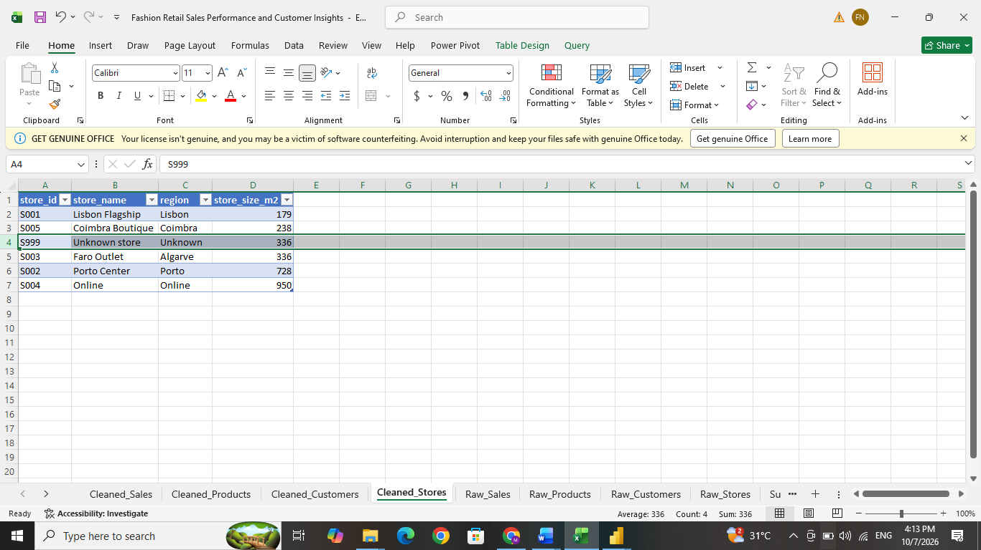

Step 7 — Apply mode imputation to selected product attributes
Invalid Category values and missing Color values were handled using mode imputation. Since both fields are categorical, the mode was used as the replacement value. In the Colour column, the most frequently occurring value was Green, so missing color values were replaced with Green.
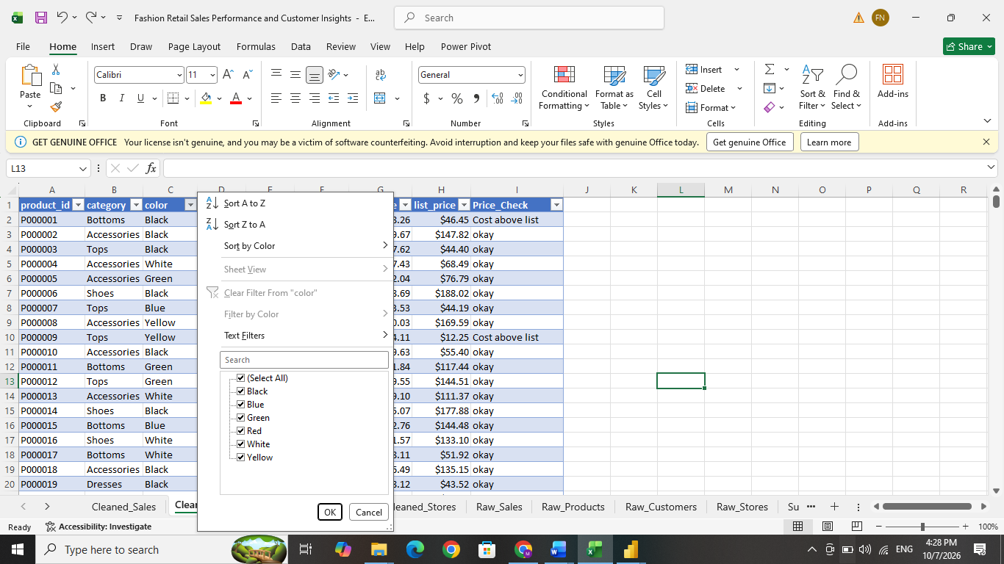
=IF(TRIM([@color])="","Green",[@color])

Field | Issue | Replacement
Category | 499 invalid ??? entries | Accessories
Colour | 990 blanks | Green

In the Category column, invalid values shown as ??? were replaced with Accessories, as Accessories was the most frequently occurring valid category.
The following formula was used:
=IF(Raw_product_data[@category]="???","Accessories",Raw_product_data[@category])
This formula checks whether the Category value is ???. If so, it replaces it with Accessories; otherwise, it keeps the original category.

Step 8 — Complete unmatched product and store references
Some Product IDs in the Sales table were not available in the corresponding Products reference table. P999999 appeared in 200 sales records, but this Product ID was not found in the Products table. This was treated as a relationship issue, not as a duplicate record. The sales transactions were keep because removing them would reduce the total transaction count and quantity sold. To maintain the relationship between the Sales and Products tables, a new record for P999999 was added to the Products table.
Since the actual product information was unavailable, several attributes were missing. Mode imputation was used for the categorical fields. The most frequently occurring valid values were used as replacements:
- Category: Accessories
- Colour: Green
- Size: XL
- Season: Winter
- Supplier: Supplier B
For Cost Price and List Price, the missing values were filled manually using the mean values calculated from the available valid records. This approach keeps all valid sales transactions in the analysis while maintaining a proper relationship between the Sales and Products tables. However, the imputed values are assumptions based on the available data and may not represent the actual details of the missing product.
.
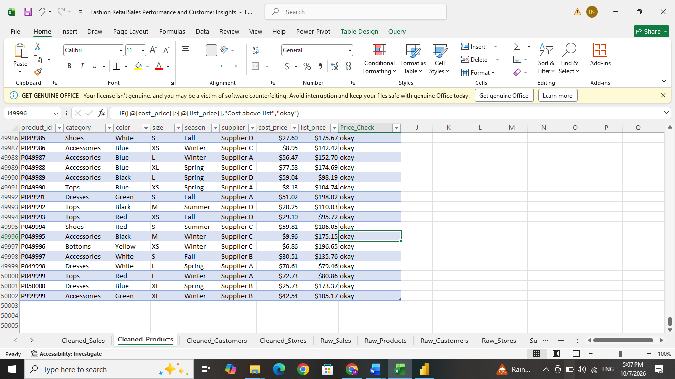

Step 9 — Add Unit_Cost and Unit_Price to Sales
Unit_Cost represents the reference cost of one product unit:
=XLOOKUP(C2,Products!$A$2:$A$50002,Products!$G$2:$G$50002,"")
Unit_Price represents the product’s reference list price before discount:
=XLOOKUP(C2,Products!$A$2:$A$50002,Products!$H$2:$H$50002,"")
Sales contained quantities and product IDs, while products contained prices. The lookup supplied the values required to calculate transaction revenue and cost. Descriptive attributes remained in Products for use through Power BI relationships.
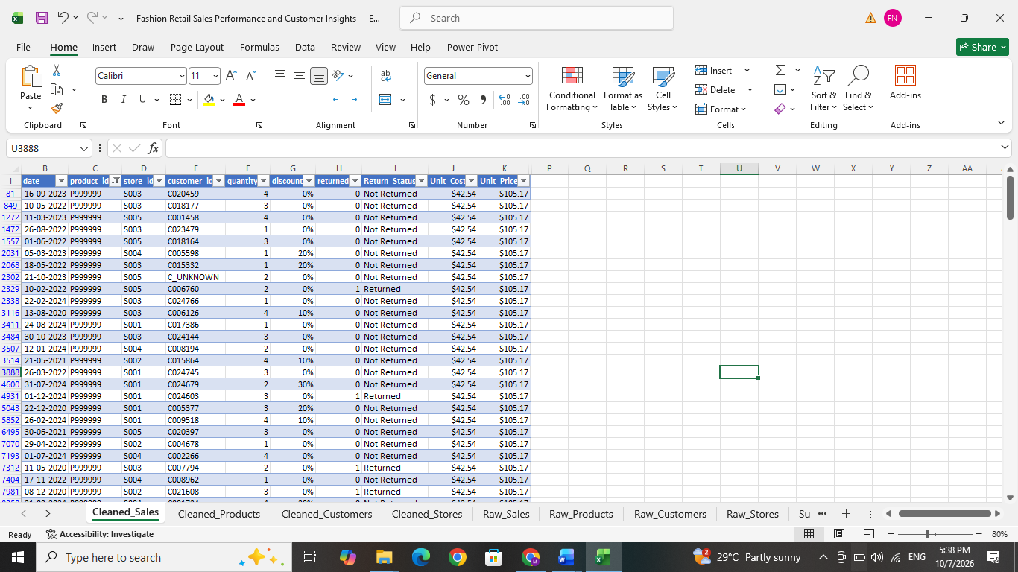

Step 10 — Add Return_Status
A new Return Status column was created in the Sales table to convert the numerical return flag into a readable category.
=IF([@returned]=1,"Returned","Not Returned")
If the return flag in column H is 1, the transaction is classified as Returned. Otherwise, it is classified as Not Returned.
Converting the numerical return flag into a descriptive label makes the data easier to understand and use in Power BI filters, tables, charts and other visuals.

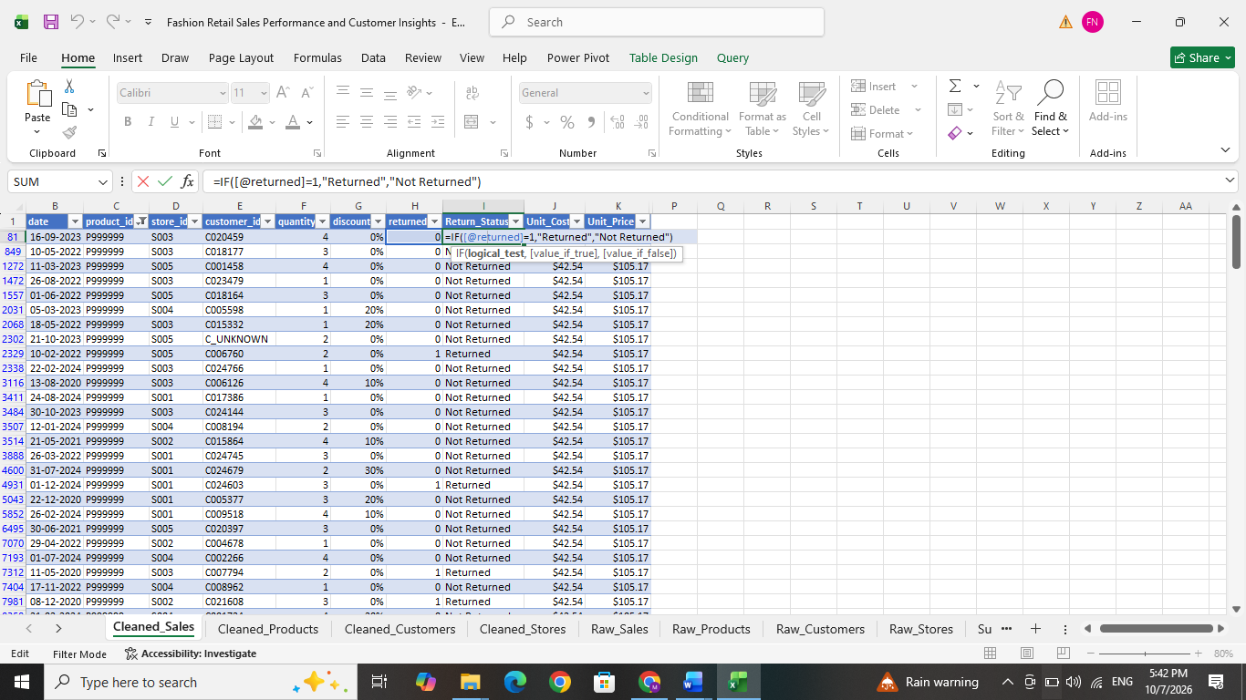

Step 11 — Add Revenue Status
A new Revenue Status column was created in the Sales table to identify whether the required financial inputs are available for revenue and cost calculations.
Formula used here =IF(OR(J81="",K81="",G81=""),"Incomplete","Ready")
The OR function checks whether Unit_Cost, Unit_Price, or Discount is blank. If any one of these fields is missing, the row is marked "Incomplete". If all three values are available, it is marked "Ready"
This helps prevent transactions with missing financial information from being treated as complete when calculating revenue, cost, and profit.
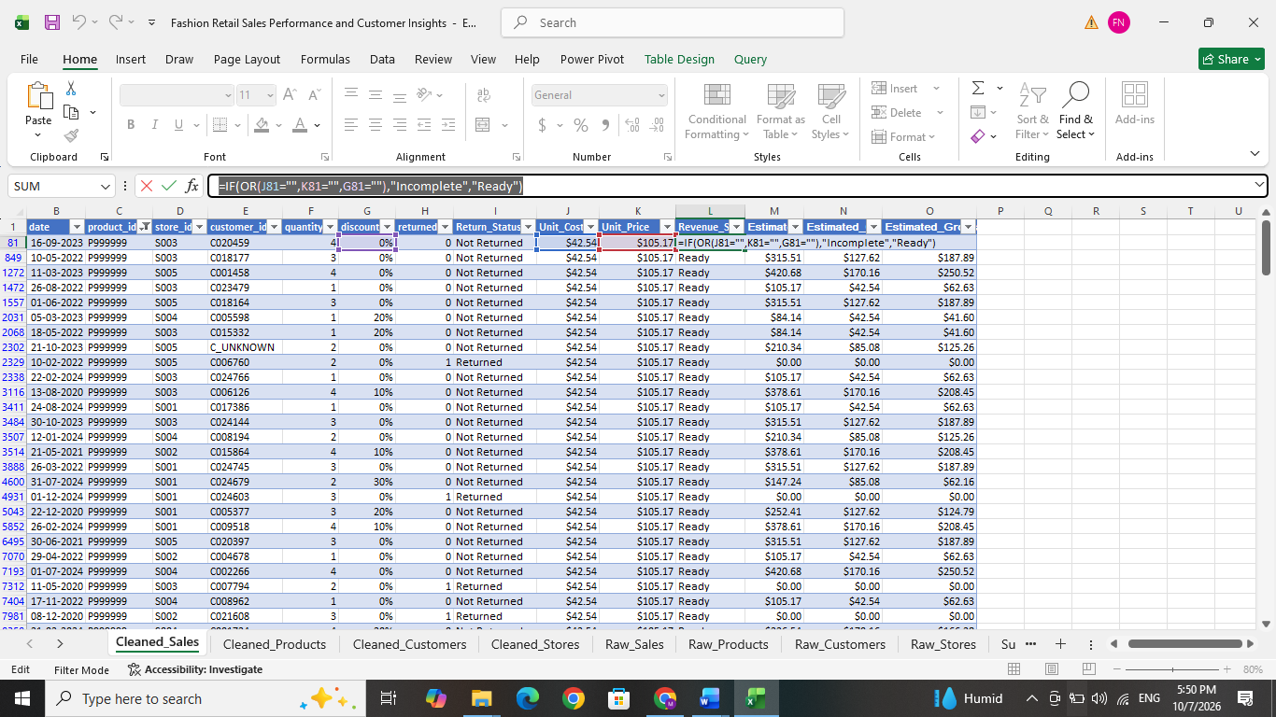

Step 12 — Add Estimated Revenue
A new Estimated Revenue column was created in the Sales table to calculate the estimated transaction revenue after discount.
Formula used =IF(L2="Incomplete","",IF(H2=1,0,ROUND(F2*K2*(1-G2),2)))
Calculation used is Quantity × Unit Price × (1 − Discount)
If the row is marked Incomplete, the result remains blank. If the transaction was returned (H2=1), the estimated revenue is set to 0. Otherwise, the formula calculates the discounted transaction revenue and rounds the result to two decimal places.
The original Sales data did not contain a transaction-level revenue amount. Therefore, revenue was estimated using the product reference list price, quantity purchased and discount applied. The field is labelled Estimated Revenue because it is calculated from reference pricing rather than an original recorded transaction amount.
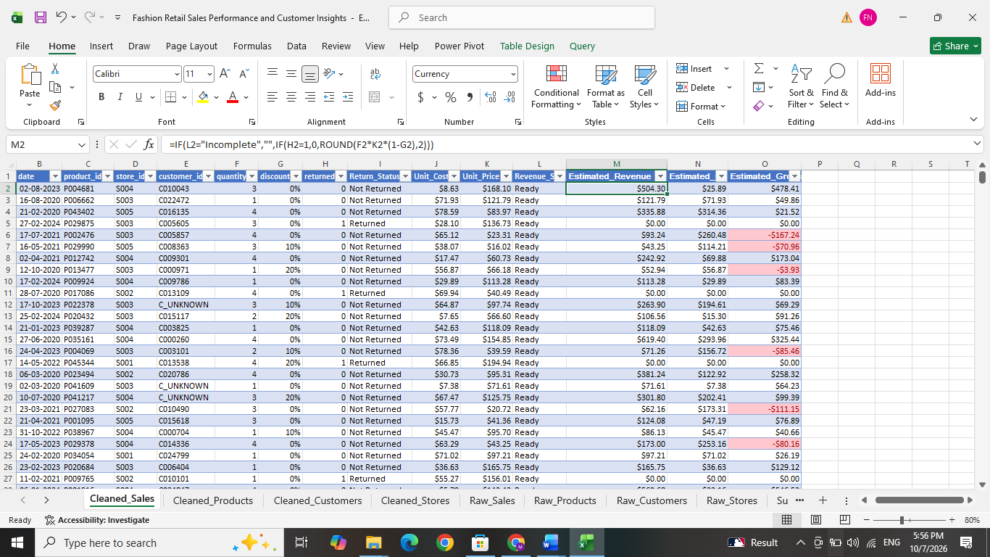

Step 13 — Add Estimated_Cost
In Sales column,
Formula used =IF(L2="Incomplete","",IF(H2=1,0,ROUND(F2*J2,2)))
The calculation uses: Quantity × Unit Cost
This estimates the cost associated with the units sold. Here the returned transactions receive zero cost as well as zero revenue.

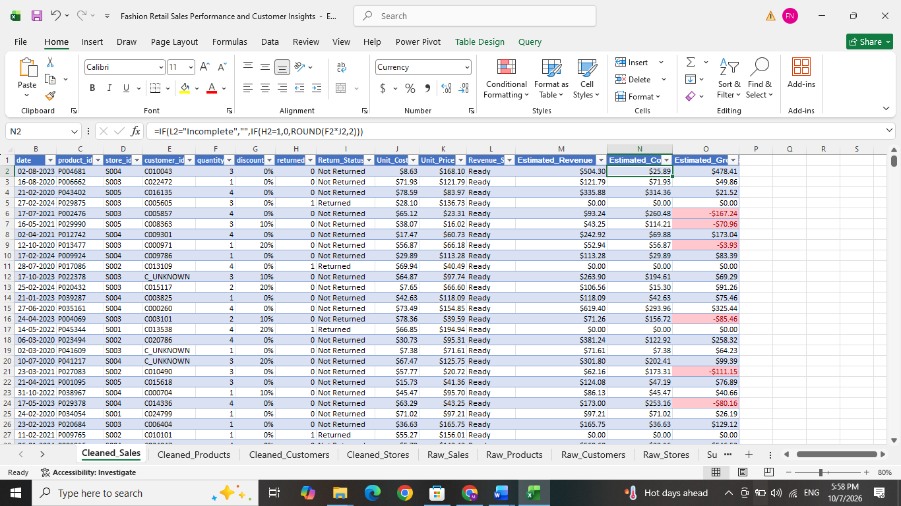

Step 14 — Add Estimated_Gross_Profit
In Sales table, the formula used is =IF(L2="Incomplete","",M2-N2)
Estimated cost is subtracted from estimated revenue. Revenue alone does not show profitability. This field allows products, stores and periods to be compared by gross profit. A negative result identifies a transaction whose estimated cost exceeds its discounted revenue.
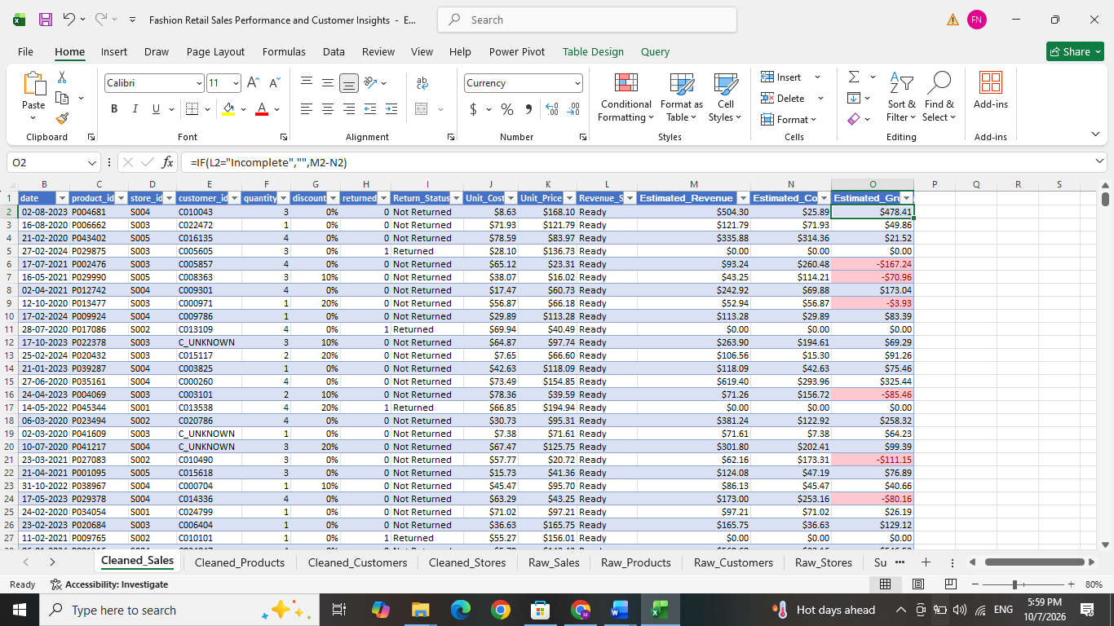

Step 15 — Add Price_Check
In Products table, the formula used here is
=IF([@[cost_price]]>[@[list_price]],"Cost above list","okay")
The formula compares each product’s cost with its list price. It identifies pricing exceptions that may explain negative gross profit. The workbook flagged 8,582 products for investigation.
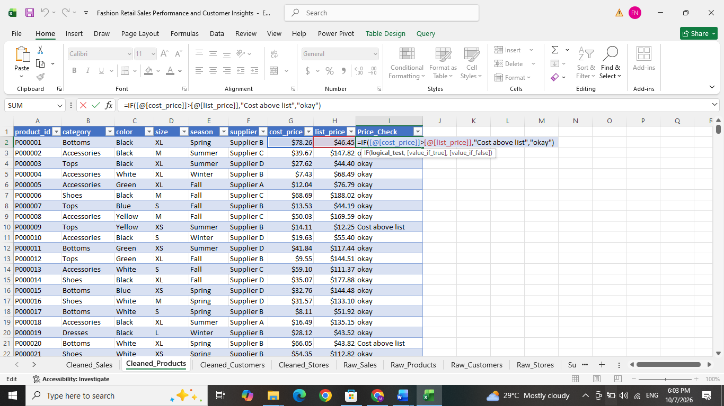

Step 15 — Add Age Group
A new AgeGroup column was created in the Customers table to convert individual ages into meaningful customer segments.
Formula used:
=IF(B2="","Unknown",IF(B2<18,"Minor",IF(B2<30,"Young Adult",IF(B2<45,"Adult",IF(B2<60,"Middle-aged Adult","Senior")))))
Age | Groups
Below 18 | Minor
18–29 | Young Adult
30–44 | Adult
45–59 | Middle-aged Adult
60 and above | Senior
The formula first checks whether Age is blank. If it is blank, the customer is classified as Unknown. Otherwise, nested IF conditions assign the customer to the appropriate age group. Age groups make customer purchasing patterns easier to compare in the dashboard than analyzing every individual age separately.
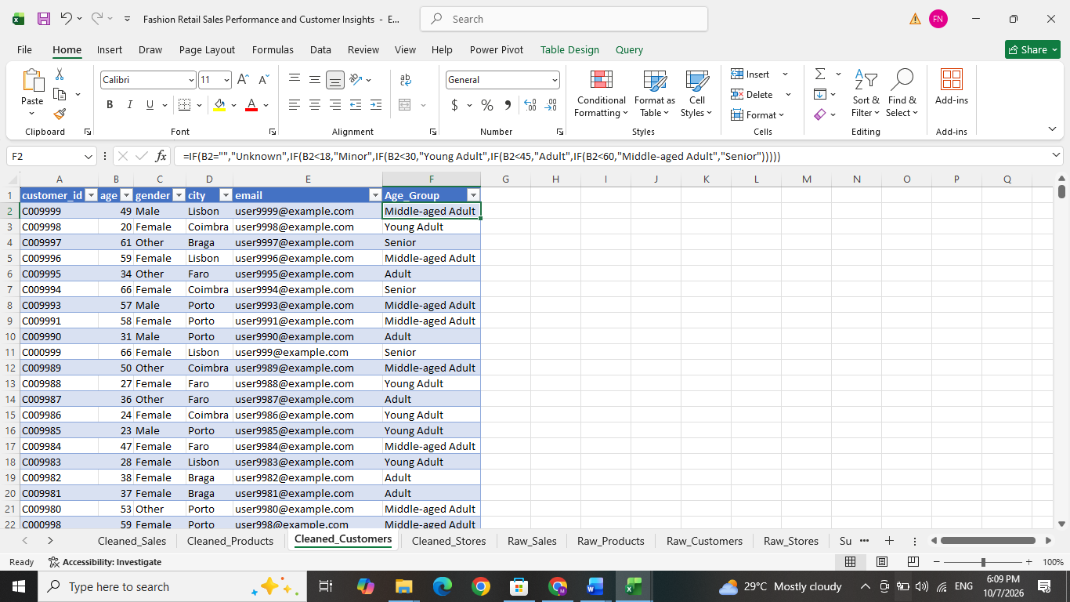

Step 17 — Apply conditional formatting and validate results
Conditional formatting helped identify exceptions and review flags. It highlighted records without changing their values. Final checks covered identifiers, lookup matches, discounts, quantities, return labels and financial formulas. All Sales rows showed Ready under the defined readiness test.
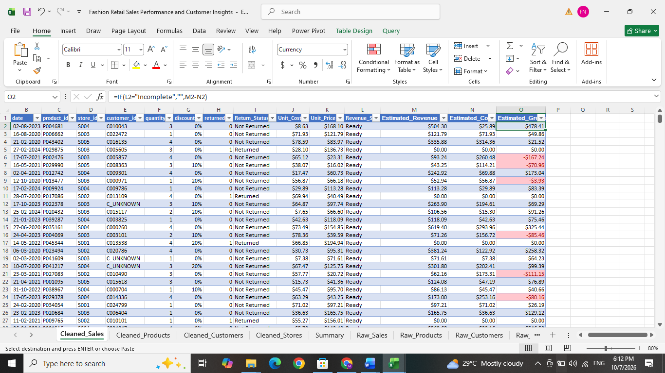

Step 18 — Create one yearly PivotTable
The Summary PivotTable used Year in Rows, which provided a small Excel analysis and total for cross checking in Power BI. The totals were 50,000 transactions, $11,234,621.25 estimated revenue and $6,434,093.54 estimated gross profit. These figures provided the reference for validating the dashboard calculations.
Value | Aggregation
Transaction ID | Count
Estimated Revenue | Sum
Estimated Gross Profit | Sum

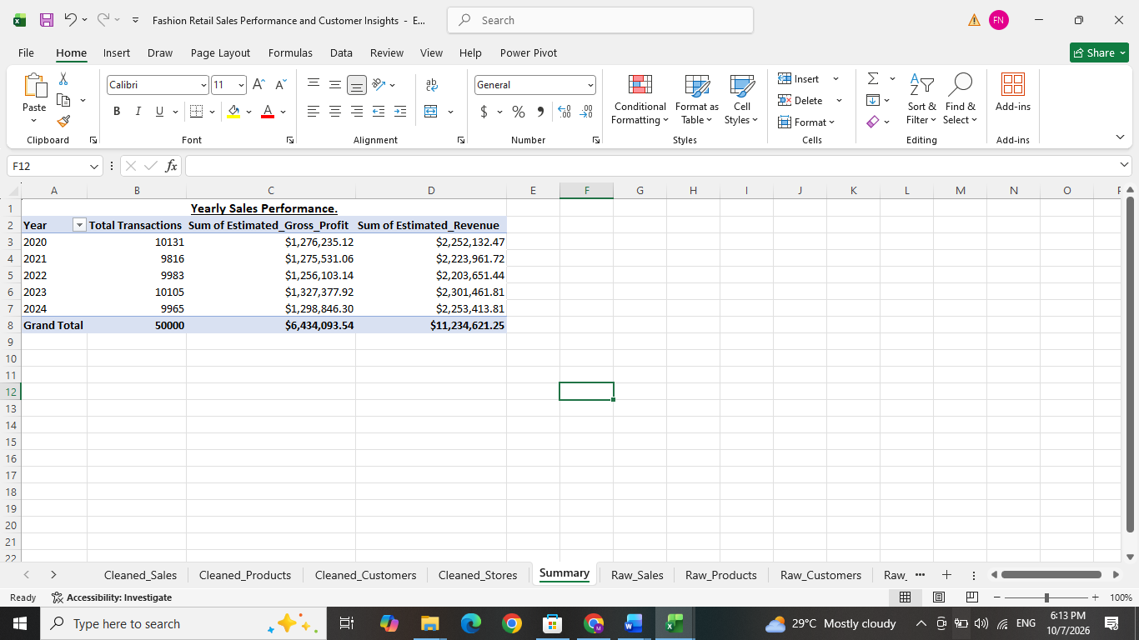

Power BI Data Modelling and DAX Calcuations
- Step -1 - Import the cleaned Excel tables
The cleaned workbook was selected through Home →Get data→Excel workbook. The four cleaned tables were imported and named Sales, Products, Customers and Stores. Transform data opened Power Query for reviewing the imported information. The Raw worksheets and Excel PivotTable remained supporting evidence in Excel. Importing the cleaned tables established a consistent source for the report and avoided loading duplicate copies of the same business data.

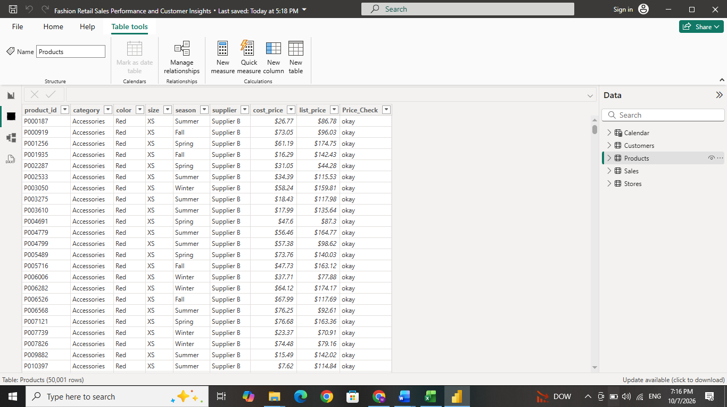

- Step 2 - Review data types and data quality
Data types were checked in Power Query before selecting Close & Apply.
Fields | Data type or display format
IDs, categories, supplier names, customer attributes and status labels | Text
Transaction date | Date
Quantity, returned flag, age and store size | Whole number
Discount | Decimal number, displayed as a percentage
Unit cost, unit price and estimated financial amounts | Fixed decimal number, displayed as currency
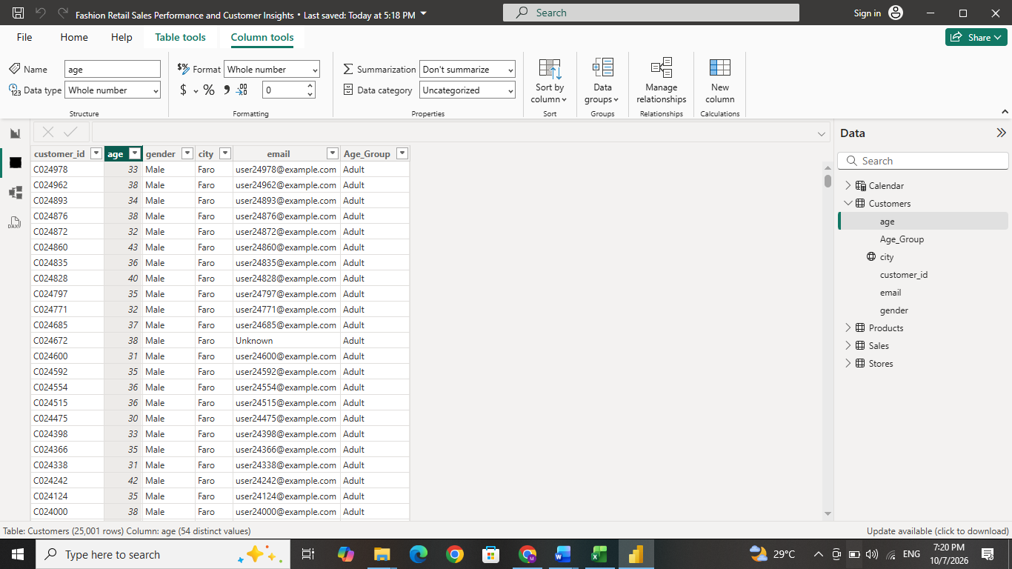

Column profiling was used to check errors, blanks and value distributions. Correct data types ensure accurate calculations and relationships, while currency and percentage formats improve readability.
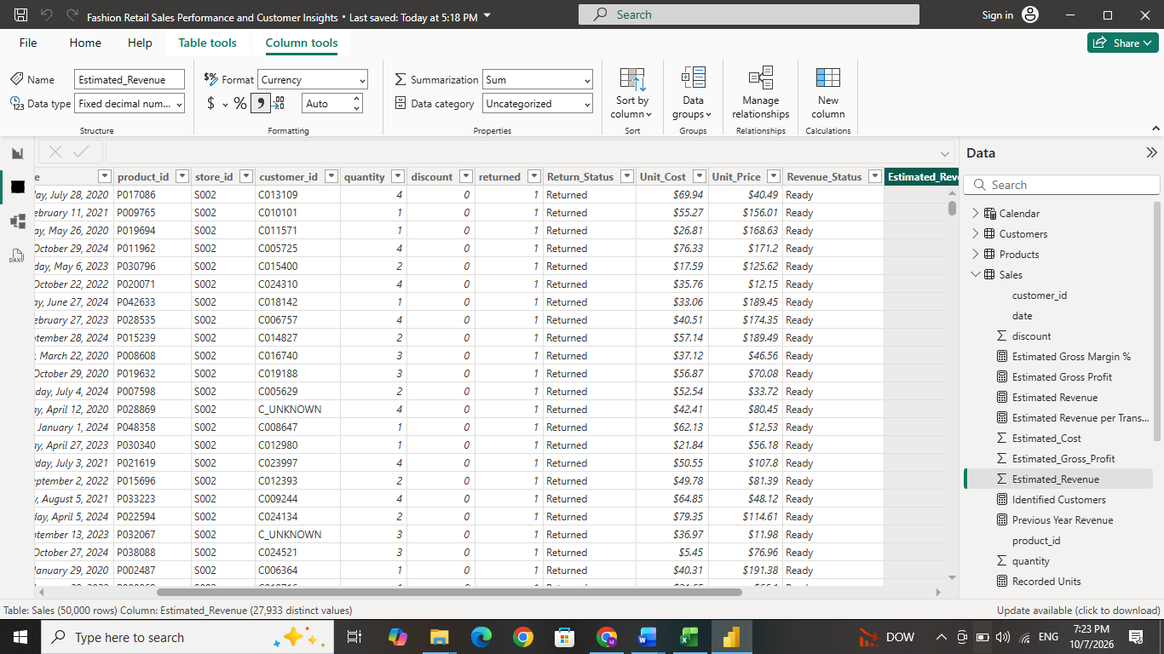

- Step 3 - Create the Calendar table
A Calendar table was created through Modeling → New table:
DAX Formula:
Calendar = CALENDAR(DATE(2020, 1, 1),DATE(2024, 12, 31))
CALENDAR creates one row for every date between the specified start and end dates. A continuous date table supports consistent monthly and yearly analysis, date slicers and previous-year comparisons.
The following columns needs to be added:
Column | DAX expression | Purpose
Year | YEAR('Calendar'[Date]) | Group results by year
Month | FORMAT('Calendar'[Date], "MMM") | Display month names
Month_Number | MONTH('Calendar'[Date]) | Sort months chronologically
Month_Year | FORMAT('Calendar'[Date], "MMM yyyy") | Display month and year together
Month_Year_Sort | YEAR('Calendar'[Date]) * 100 + MONTH('Calendar'[Date]) | Sort Month_Year correctly
Month_Start | DATE(YEAR('Calendar'[Date]), MONTH('Calendar'[Date]), 1) | Represent the first day of each month

Month was sorted by Month_Number, and Month_Year was sorted by Month_Year_Sort. Calendar was then marked as the date table using its Date column.
- Step 4 - Create relationships between the tables
Sales was used as the central transaction table. Products, Customers, Stores and Calendar supplied information for filtering and grouping.
Reference table and field | Sales field | Relationship
Products[product_id] | Sales[product_id] | One-to-many
Customers[customer_id] | Sales[customer_id] | One-to-many
Stores[store_id] | Sales[store_id] | One-to-many
Calendar[Date] | Sales[date] | One-to-many

Relationships were active, with single-direction filtering from the reference tables to Sales. This structure allows a selected category, customer group, store or date to filter the related transactions. It keeps descriptive information in its own table while financial calculations remain in Sales. This arrangement is called a star schema.
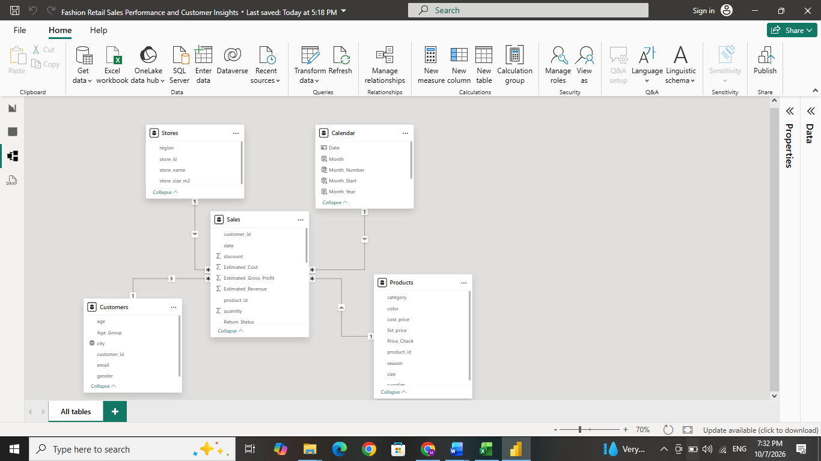

- Step 5 - Create financial performance measures
DAX measures were created through Modeling → New measure. Each definition below represents a separate measure.
DAX Measure : Estimated Revenue = SUM(Sales[Estimated_Revenue])
This adds the Excel-calculated revenue for the transactions included in the current selection.
DAX Measure : Estimated Gross Profit = SUM(Sales[Estimated_Gross_Profit])
This adds the estimated gross profit for the selected transactions.
DAX Measure : Estimated Gross Margin % = DIVIDE([Estimated Gross Profit],[Estimated Revenue])
Gross Profit Margin shows profit as a percentage of revenue. For example, a 50% margin means half of the revenue is gross profit. The measure responds to report filters, while DIVIDE safely handles zero revenue by returning blank.
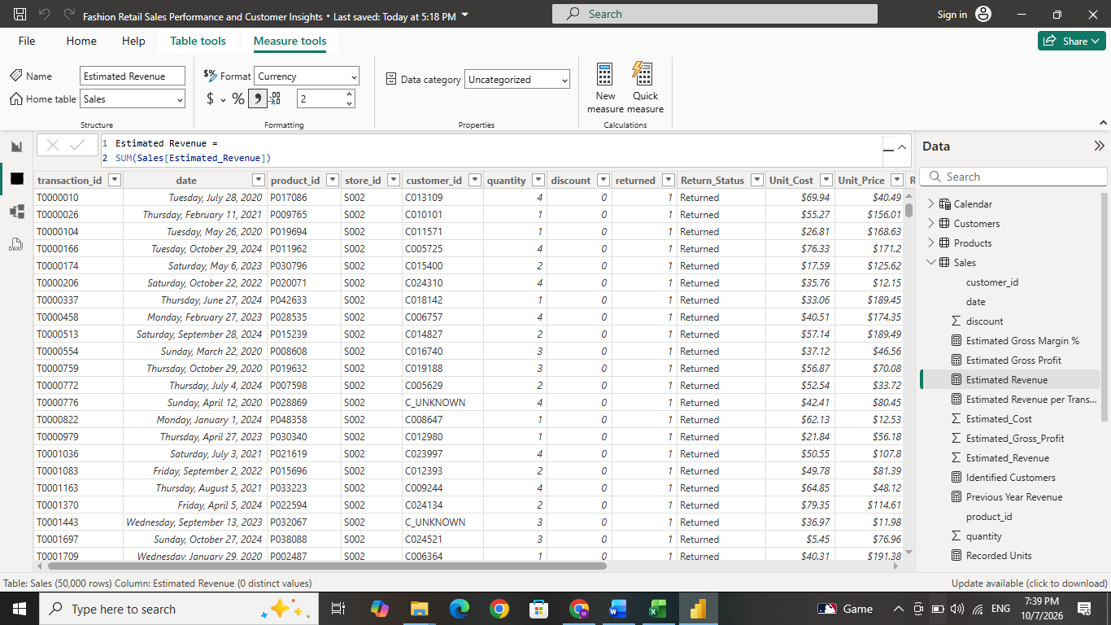

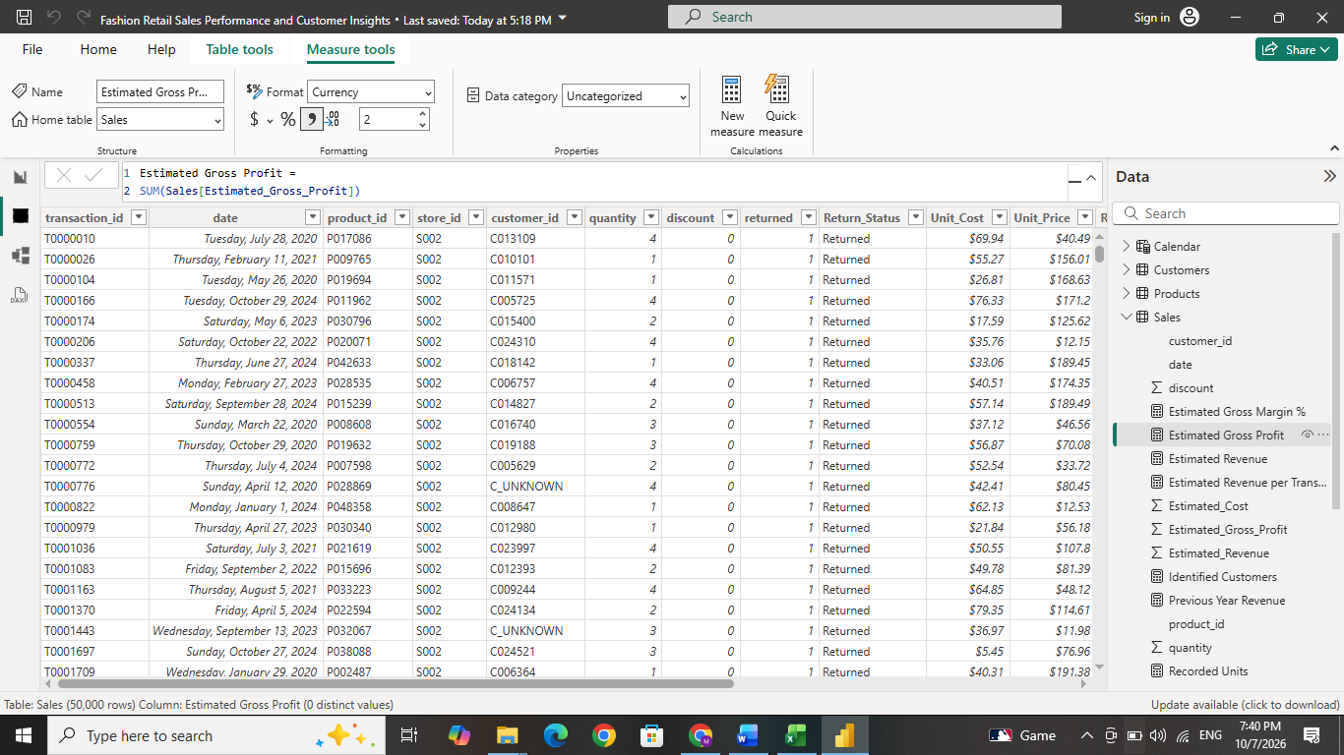

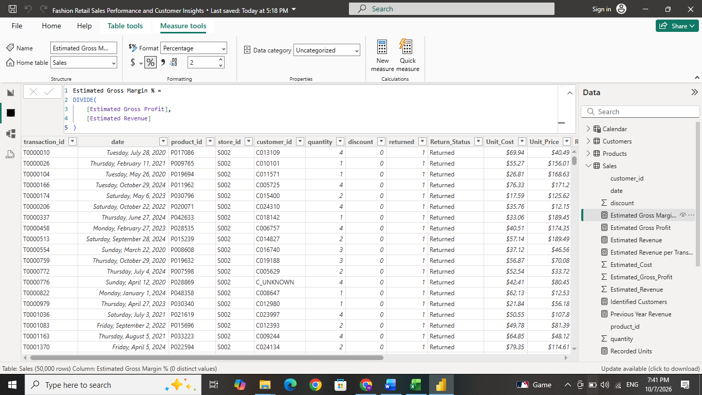

- Step 6 - Create transaction and quantity measures
DAX Measures: Total Transactions =COUNTROWS(Sales)
This counts Sales rows. Each row represents one transaction in this dataset. It measures the volume of transaction activity.
DAX Measures: Recorded Units = SUM(Sales[quantity])
This adds the quantities recorded in Sales. It measures recorded product volume. Both measures include returned transactions; therefore, Recorded Units should not be described as units retained after returns.
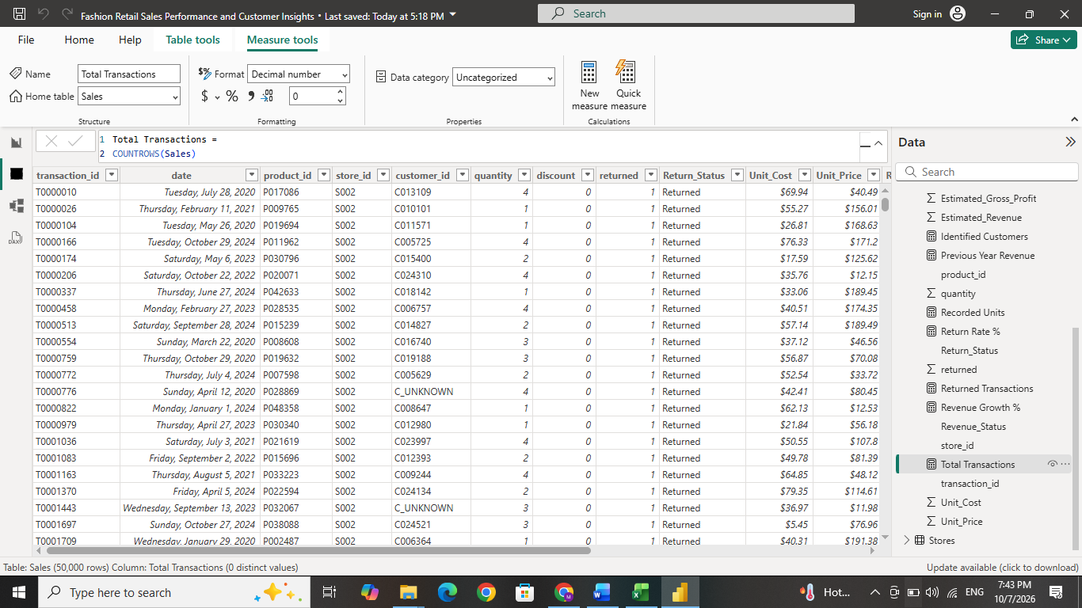

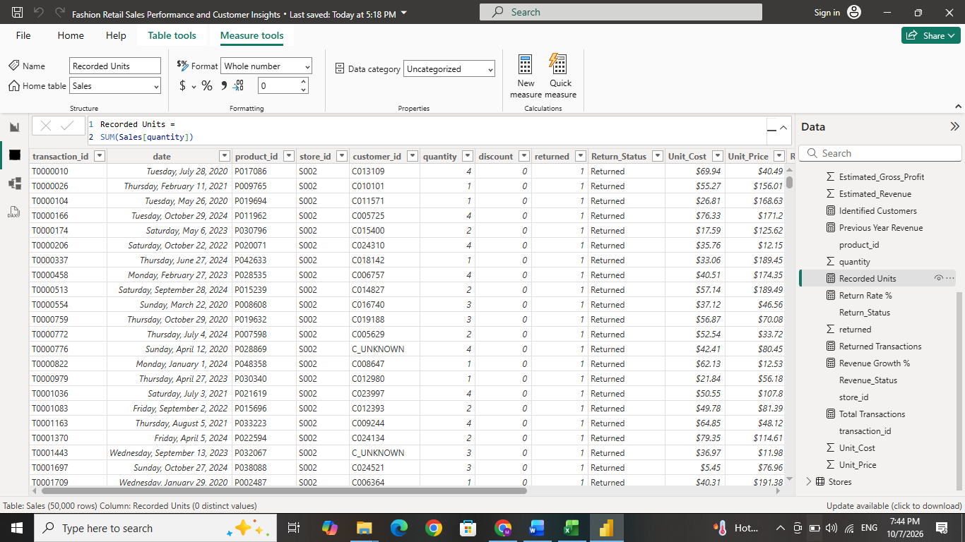
- Step 7 - Create return measures
DAX Measures : Returned Transactions =CALCULATE([Total Transactions],Sales[returned] = 1)
CALCULATE evaluates the transaction count with the condition that the return flag equals 1.
DAX Measures : Return Rate % =DIVIDE([Returned Transactions],[Total Transactions])
The count shows how many transactions were returned, while the percentage allows return levels to be compared across categories, stores and periods.
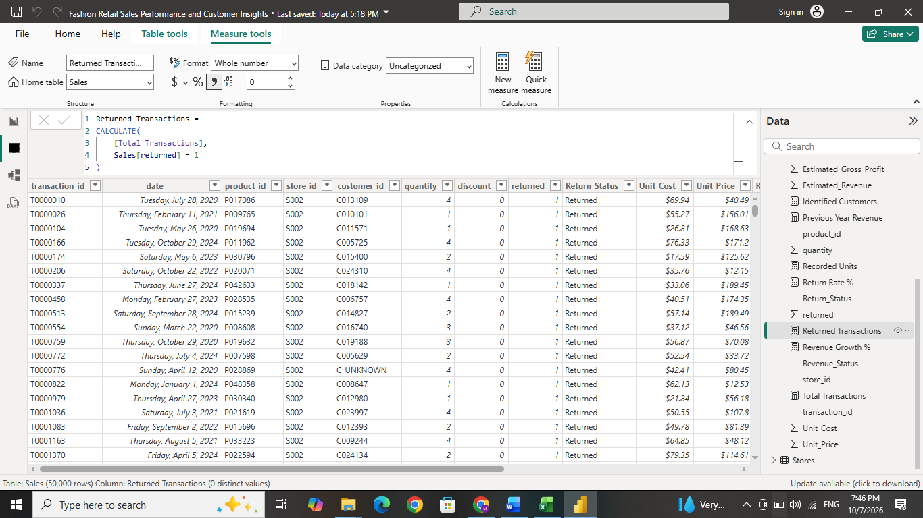

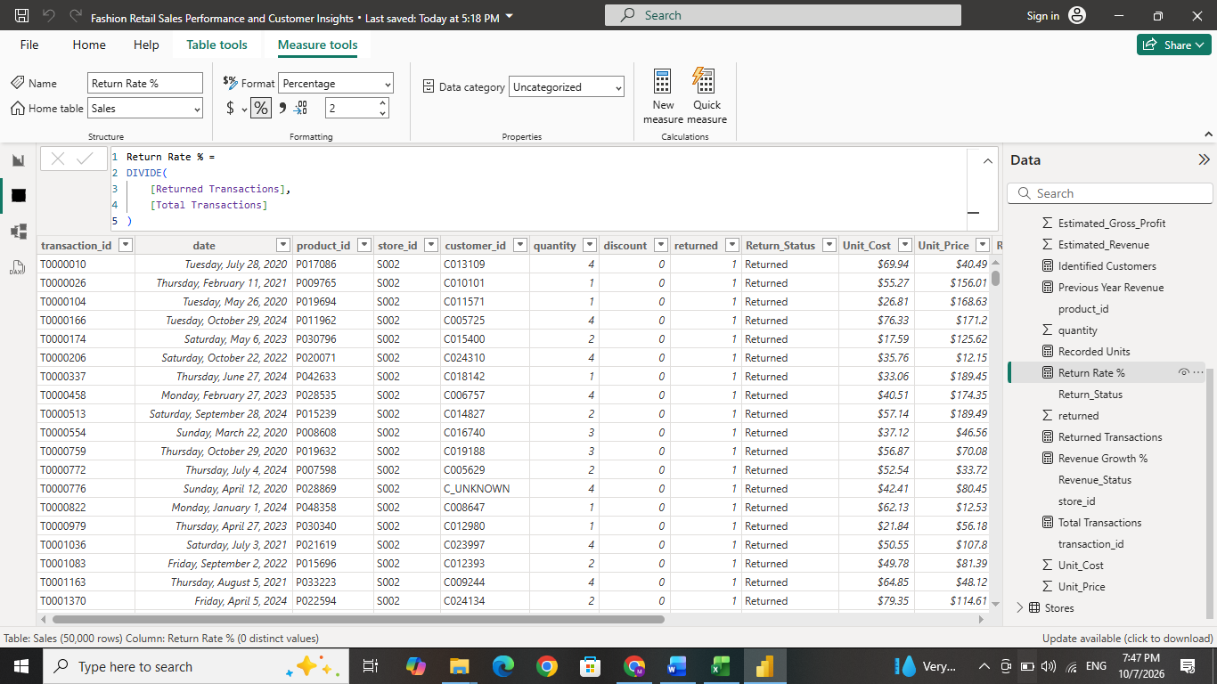

- Step 8 - Create customer and purchasing measures
DAX Measures : Identified Customers =CALCULATE(DISTINCTCOUNT(Sales[customer_id]),Sales[customer_id] <> "C_UNKNOWN")
DISTINCTCOUNT counts each identified purchasing customer once within the current filter selection. The placeholder customer is excluded so unidentified transactions are not treated as one real customer.
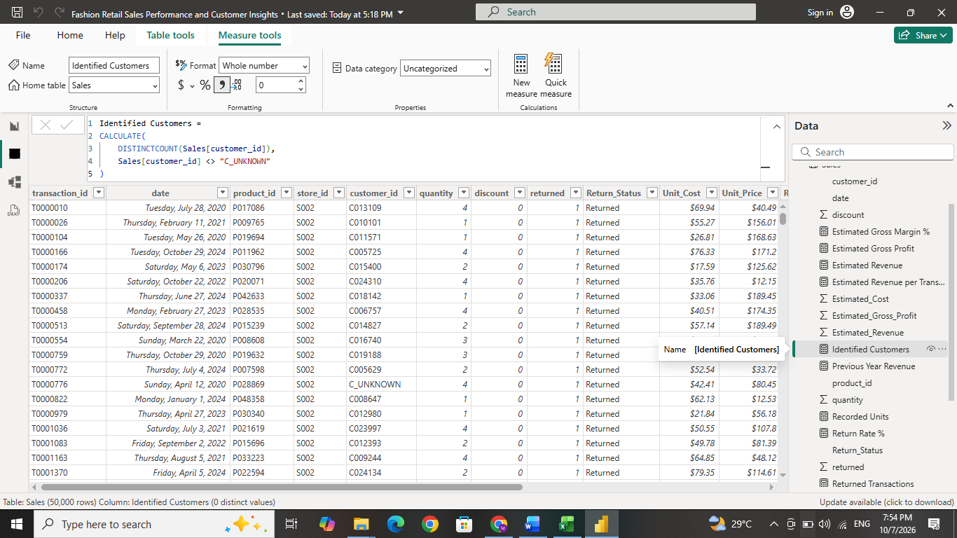

DAX Measures : Estimated Revenue per Transaction =DIVIDE([Estimated Revenue],[Total Transactions])
This indicates average estimated revenue across all recorded transactions. Its denominator includes returned transactions. The Average Units per Transaction card used the Average aggregation of Sales[quantity]. It showed how many units were recorded per transaction on average.
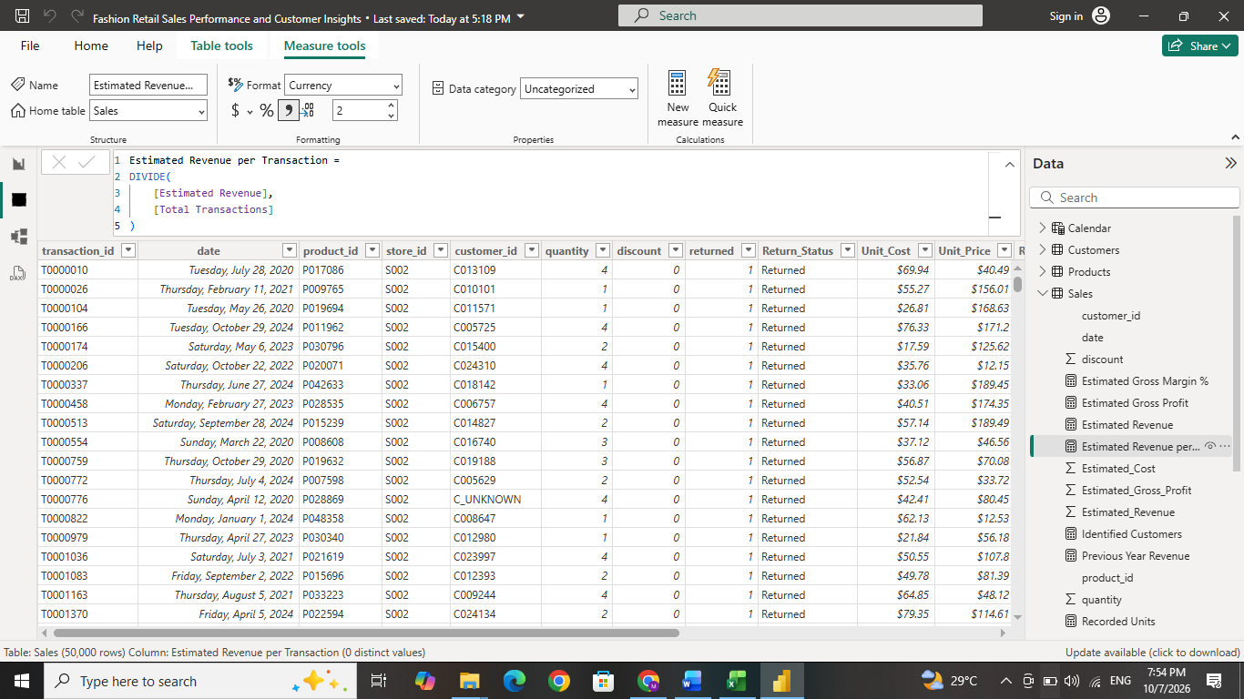

- Step 9 - Create previous-year and growth measures
DAX Measure :
Previous Year Revenue =
IF(
HASONEVALUE('Calendar'[Year]),
CALCULATE(
[Estimated Revenue],
SAMEPERIODLASTYEAR('Calendar'[Date])
),
BLANK()
)
SAMEPERIODLASTYEAR shifts the date selection to the corresponding previous-year period. HASONEVALUE limits the comparison to a single year in the current context. This supports meaningful year-on-year comparisons and avoids presenting a misleading combined multi-year result.

DAX Measure :
Revenue Growth % =
DIVIDE(
[Estimated Revenue] - [Previous Year Revenue],
[Previous Year Revenue]
)
The difference between current and previous-year revenue is divided by previous-year revenue. It shows whether revenue increased or decreased. The first year has no previous-year comparison within the available date range.
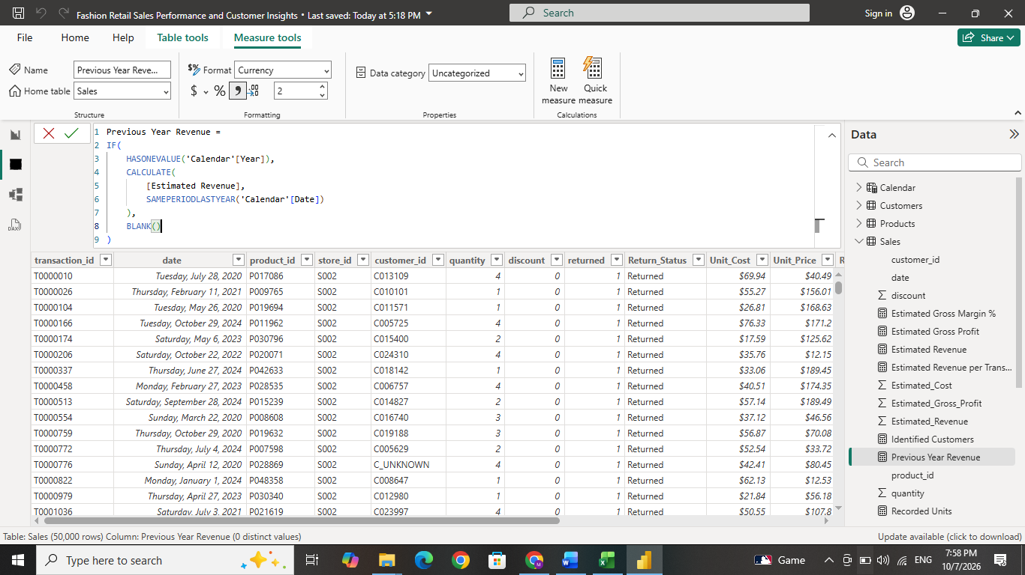

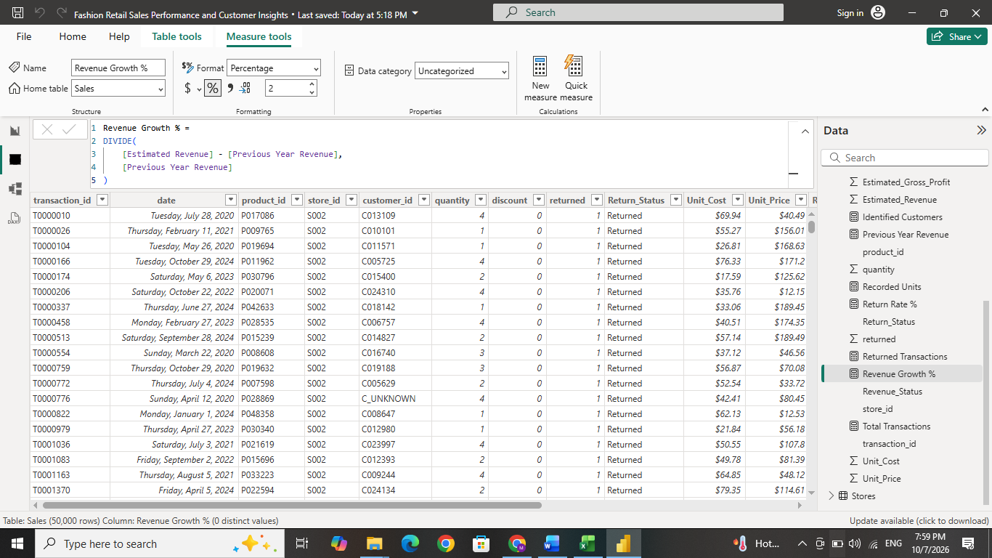

- Step 10 - Format the measures and design the report
Financial measures were displayed as currency, ratios as percentages and counts as whole numbers. Average units were displayed with decimal places. The report used a 16:9 landscape canvas and a consistent streetwear-inspired color scheme. Card positions, chart spacing, navigation and slicer placement were coordinated across the three pages. Consistent formatting makes the report easier to read and compare. The word Estimated remained in financial labels to communicate how the figures were calculated.

- Step 11 - Create the three report pages
Page | Main indicators and visuals | Analytical purpose
Sales Overview | Revenue, gross profit, margin, transaction and return-rate cards; monthly revenue and profit line chart; category bar chart | Present overall performance and changes over time
Products & Stores | Recorded units and gross profit cards; revenue and margin combination chart; store bar chart; supplier treemap; category–season matrix | Compare commercial contributions across categories, suppliers and stores
Customer Insights | Identified customers, average units, revenue per transaction and returned-transaction cards; age-group bar chart; gender doughnut; city map | Examine customer activity and geographical distribution

The monthly chart used Month_Year with Estimated Revenue and Estimated Gross Profit. Customer age and gender visuals counted transactions, while the city map showed distinct identified purchasing customers. Product season was treated only as a catalogue attribute.
Year, Store and Category slicers were synchronized across pages. Navigation buttons, Reset Filters and tooltips improved usability and allowed users to explore the report while keeping selections consistent.

Dashboard Design
An interactive Power BI dashboard was developed to analyses historical fashion sales from 2020 to 2024. The dashboard converted the cleaned Excel data into visual summaries of revenue, estimated gross profit, transaction volumes, product performance, store contributions and customer purchasing activity.
The report was organized into three connected pages:
Sales Overview, Products & Stores, and Customer Insights.
Each page addressed a specific analytical objective and included relevant KPI cards, charts and filtering options.
Sales Overview
This page presented the main financial and operational results, allowing users to understand overall performance before exploring individual products, stores or customer groups.
Five KPI cards summarized the complete dataset:
Performance indicator | Result | Description
Estimated Revenue | $11,234,621.25 | Estimated sales value after discounts and the project’s treatment of returns.
Estimated Gross Profit | $6,434,093.54 | Estimated revenue after deducting estimated product costs.
Estimated Gross Margin | 57.27% | Estimated gross profit as a percentage of estimated revenue.
Total Transactions | 50,000 | Total recorded transactions, including returns.
Return Rate | 9.92% | Percentage of transactions marked as returned.

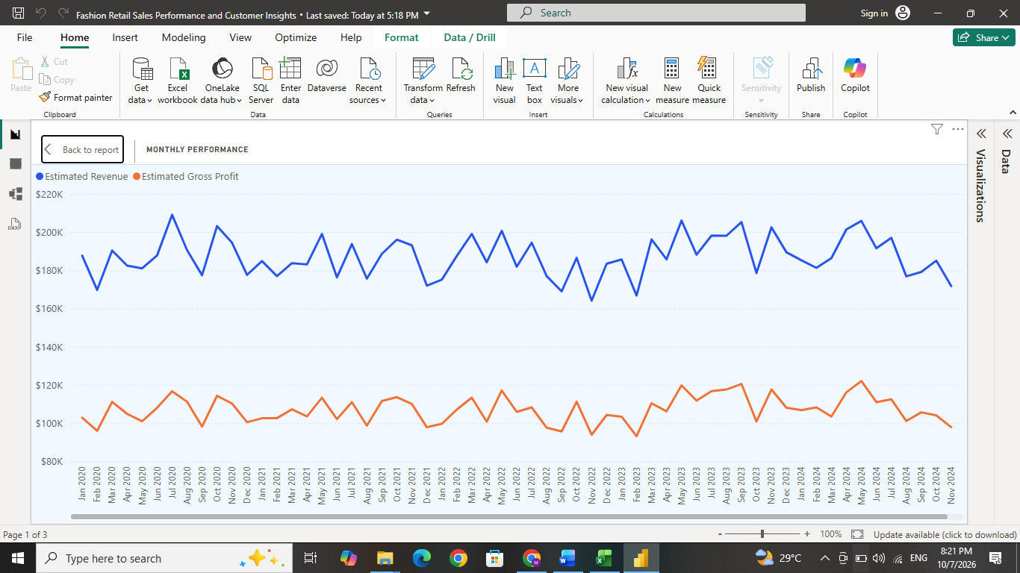
- A Monthly Performance line chart displayed estimated revenue and estimated gross profit across the reporting period. Which is selected from Build visuals. The horizontal axis used the Calendar table’s Month–Year field, while two differently colored lines represented the financial measures. This visual supported the identification of monthly fluctuations and comparisons between revenue growth and gross profit performance.

- A Revenue by Category bar chart compared the contributions of Accessories, Shoes, Dresses, Tops and Bottoms. The visual helped identify categories generating larger or smaller amounts of revenue. These comparisons provided a basis for reviewing product assortment, promotional priorities and stock allocation. In x axis we put estimated revenue measure and in y- axis we put category.
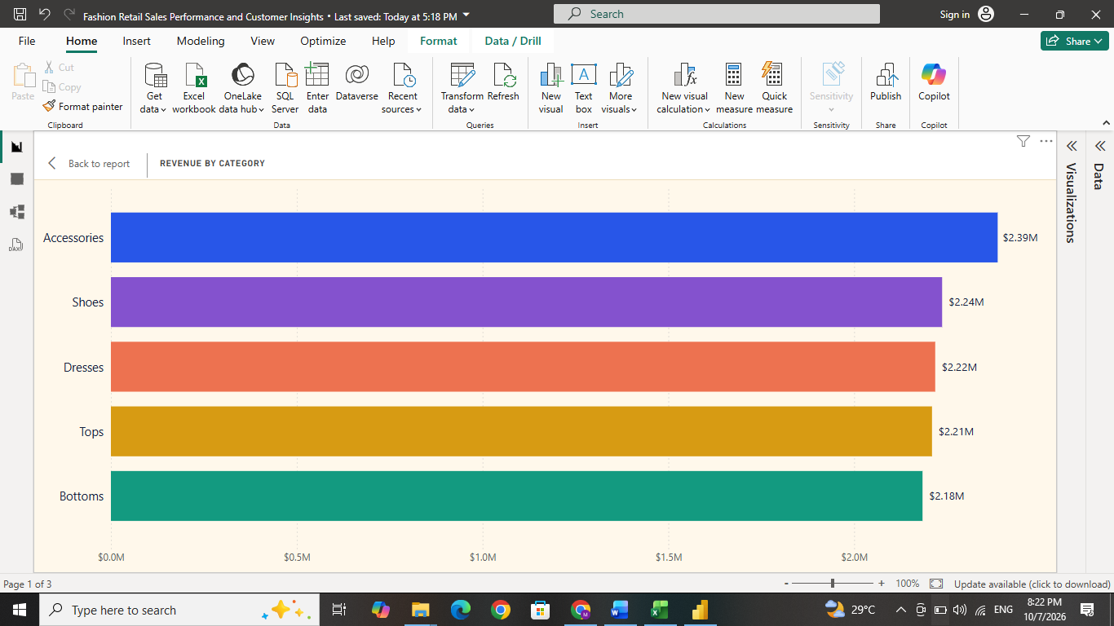

Products & Stores
This page examined the contribution of product categories, suppliers and sales locations. KPI cards displayed 125,324 recorded units and $6,434,093.54 in estimated gross profit for the complete dataset. Both indicators responded to the selected filters.
Four visuals supported the detailed analysis:
Visual | Information presented | Purpose
Category Revenue & Margin — combination chart | Estimated revenue appeared as columns, with estimated gross margin percentage represented by a line.  X-axis - Products[category]  Column Y-axis[Estimated Revenue]  Line Y-axis[Estimated Gross Margin %] | Compared the sales contribution and gross margin of each category.
Store Performance — bar chart | Estimated revenue was grouped by store.  Y-axis - Stores[store_name]  X-axis - [Estimated Revenue] | Compared store contributions and identified locations requiring further investigation.
Revenue by Supplier — treemap | Rectangle sizes represented revenue associated with each supplier’s products.  Category - Psroducts[supplier]  Values - [Estimated Revenue]  Tooltips - [Estimated Gross Profit] | Showed the distribution of revenue across suppliers.
Category & Season Revenue — matrix | Categories appeared in rows, product seasons in columns, and estimated revenue in the cells.  Rows - Products[category]  Columns - Products[season]  Values- [Estimated Revenue] | Provided detailed comparisons across category–season combinations.

The combination chart compared revenue with margin, showing that high revenue does not always mean high profitability. Store and supplier visuals supported performance comparisons across locations and suppliers.
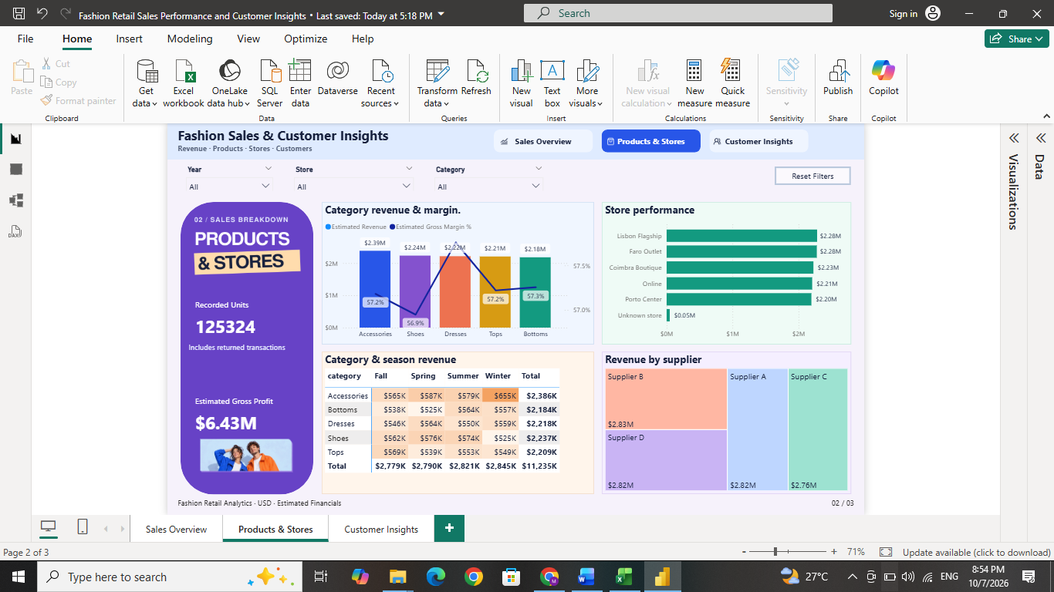
Product season represented catalogue classifications such as Summer or Winter. Therefore, the matrix compared revenue by product season category, not customer purchasing seasonality based on transaction dates.

Customer Insights
This page examined purchasing activity across customer groups and geographical locations. Four KPI cards summarized the customer-related indicators.
Performance indicator | Result | Description
Identified Customers | 21,275 | Distinct purchasing customer IDs, excluding the C_UNKNOWN placeholder.
Average Units per Transaction | 2.51 | Average quantity recorded per transaction.
Estimated Revenue per Transaction | $224.69 | Estimated revenue divided by total recorded transactions.
Returned Transactions | 4,959 | Number of transactions recorded as returned.

- Transactions by Age Group bar chart - compared transaction volumes across the age groups created during Excel processing. It supported the examination of purchasing activity across different customer age groups. Tooltips provided additional information, including estimated revenue per transaction and return rate. Y-axis - Customers[Age_Group] , X-axis - [Total Transactions] , Tooltips - [Estimated Revenue per Transaction] and [Return Rate %]
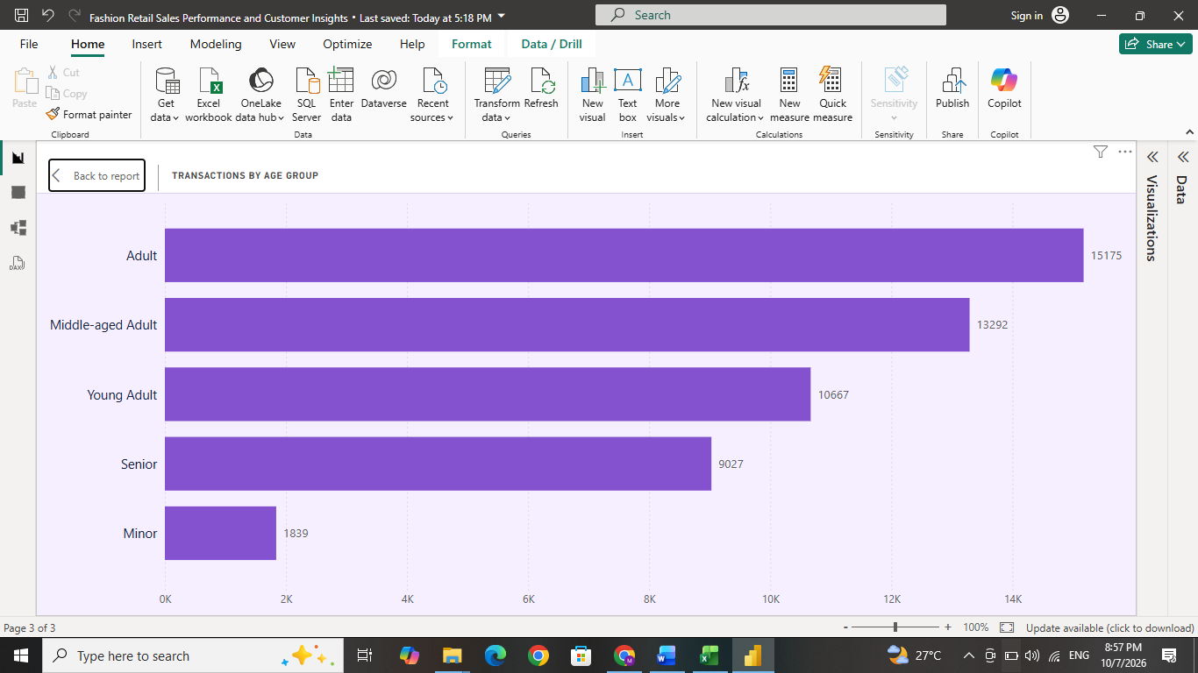

- Transactions by Gender doughnut chart - displayed each recorded gender category’s share of transactions. Percentage labels made the distribution easier to interpret. The chart described recorded purchasing activity rather than the proportion of unique customers in each gender category.
Legend - Customers[gender] , Values - [Total Transactions] , Tooltips - [Return Rate %]
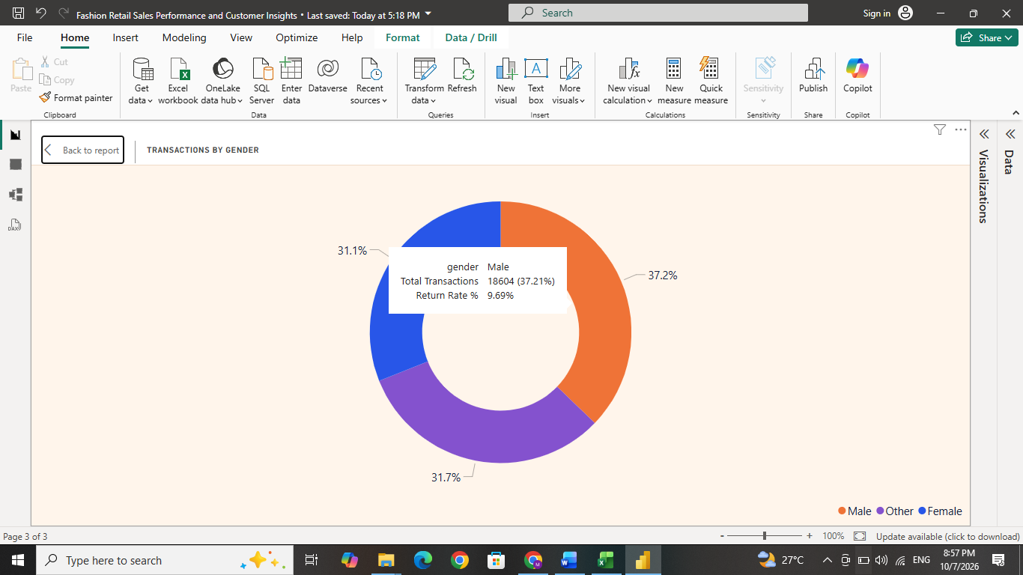

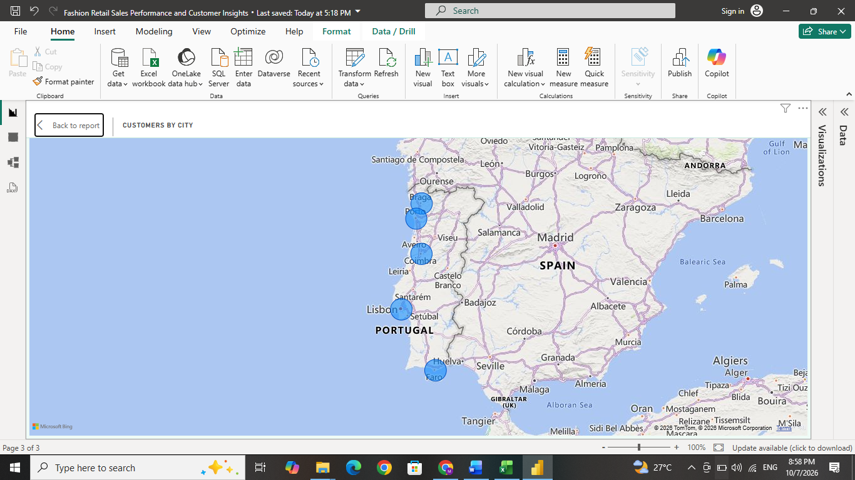
- Customers by City map - displayed the geographical distribution of identified purchasing customers. Bubble sizes represented distinct customer counts, while tooltips provided transaction counts and estimated revenue per transaction. This visual supported the identification of locations with larger concentrations of existing customers. Location - Customers[city],
Size/Bubble -size[Identified Customers]
Tooltips -[Total Transactions] and [Estimated Revenue per Transaction]

The age and gender charts measured transaction activity, while the city map showed distinct customers, since one customer could make multiple purchases.
Year, Store and Category slicers were synchronized across all three pages, allowing users to keep the same selections while moving through the report. KPI cards and charts updated automatically based on the active filters.
Navigation buttons, a Reset Filters button and tooltips improved usability. For example, selecting a specific year and category allowed users to compare financial results, store performance and customer activity under the same filter conditions.

Dashboard design and formatting
- All pages used a 16:9 landscape canvas (1280 × 720 pixels).
- A consistent fashion and streetwear-inspired color scheme used blue, orange, purple and mint tones.
- Light backgrounds and dark text were used to improve readability.
- KPI cards displayed large numerical values with smaller descriptive labels.
- Financial measures were formatted as currency.
- Ratios were formatted as percentages.
- Counts were shown as whole numbers.
- Average units retained decimal places.
- Large financial values were displayed in shortened units where appropriate.
- Line charts showed changes over time.
- Bar charts supported category and store comparisons.
- Doughnut charts displayed proportions.
- Treemaps showed relative contribution.
- Matrices presented detailed values.
- Maps displayed geographical distribution.

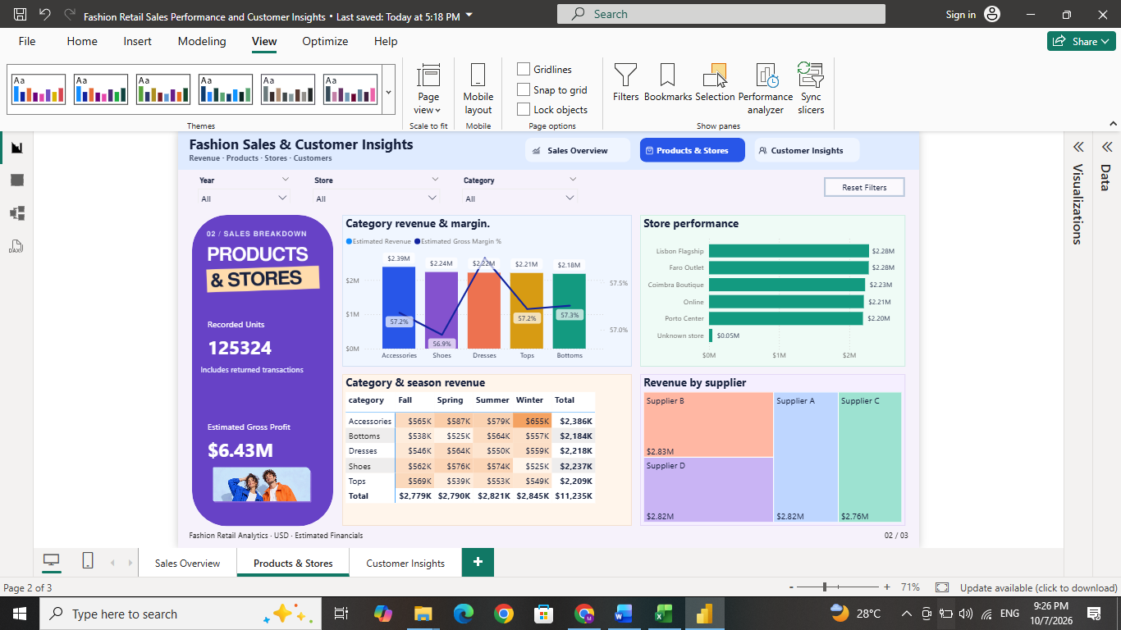

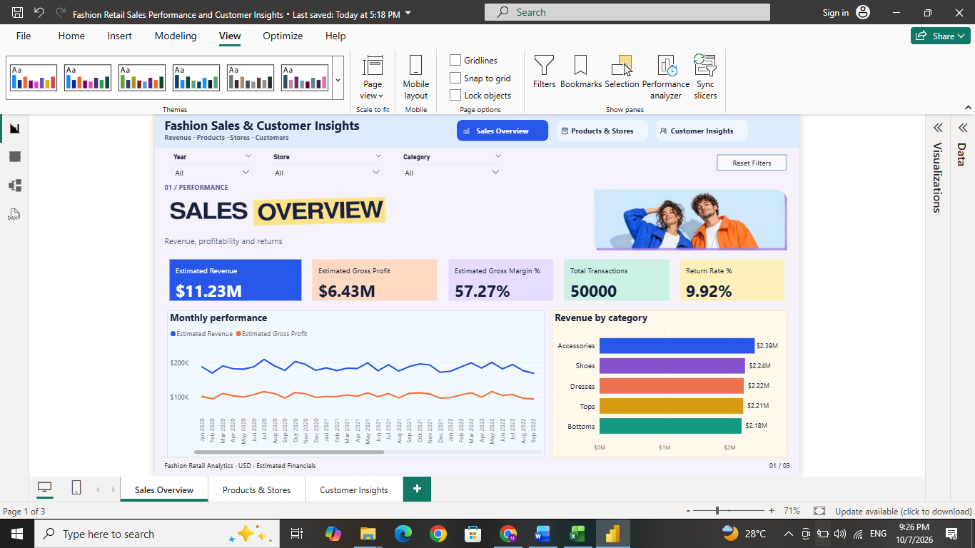

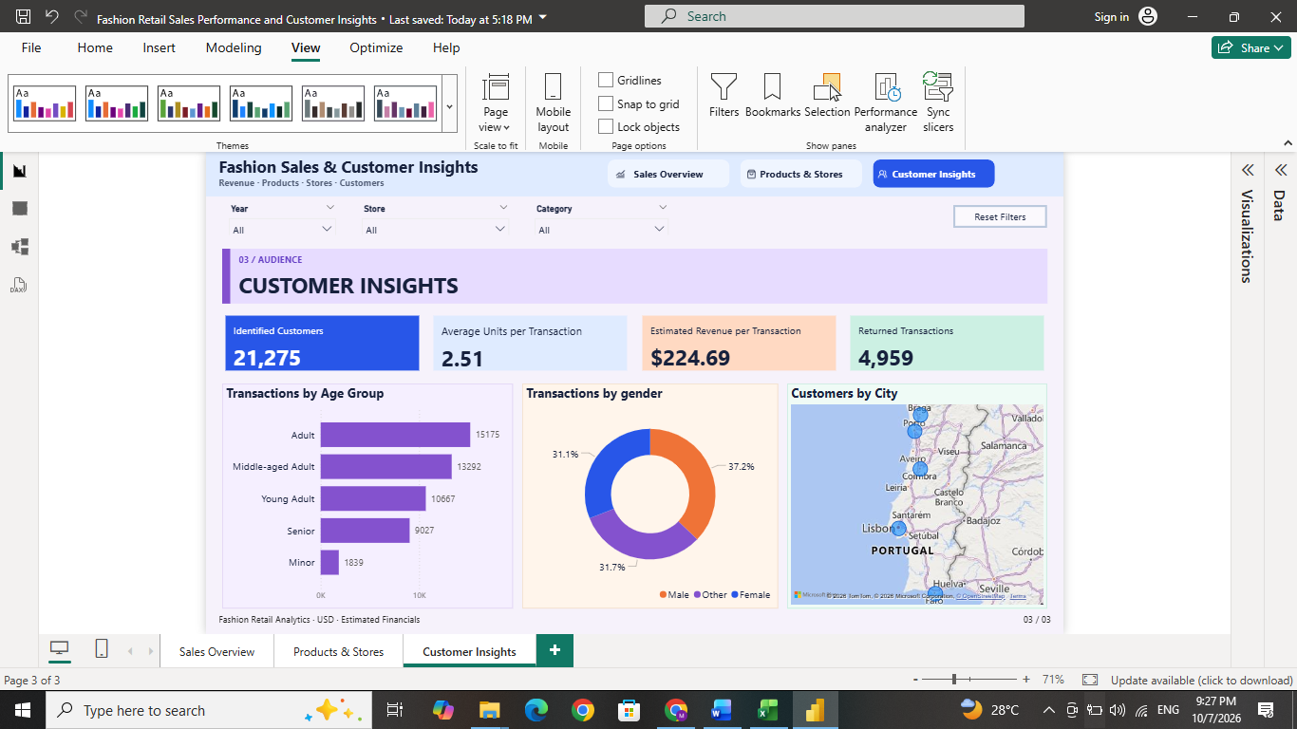
Validation and interpretation
The dashboard totals were validated against the yearly Excel PivotTable, and total transactions, estimated revenue and estimated gross profit matched between Excel and Power BI. The financial results were treated as estimates for a hypothetical retail case study, with the dollar symbol used as a presentation assumption. Estimated gross profit excluded operating expenses. Returned transactions contributed zero estimated revenue and gross profit but were still included in transaction and recorded-unit counts. Customer and product analysis was also influenced by missing-value treatment and imputation assumptions, so the unknown-customer demographic values needed correction before drawing final age- and gender-based conclusions.

Analysis Summary
This project analyzed 50,000 fashion sales transactions recorded between 2020 and 2024 using Microsoft Excel and Power BI. Four related datasets—Sales, Products, Customers and Stores—provided the information required for the analysis.
Excel was used to check data quality, standardize formats and labels, treat missing values, retrieve product prices and costs, and calculate estimated revenue, cost and gross profit. A yearly PivotTable summarized the results and supported validation.
Power BI was used to establish relationships, create measures and develop three interactive pages: Sales Overview, Products & Stores, and Customer Insights. Filters, navigation buttons and tooltips enabled users to explore performance across years, categories, stores and customer groups.
Key performance indicators
The following results represent the complete dataset with no filters applied.
KPI | Result
Total Transactions | 50,000
Estimated Revenue | $11,234,621.25
Estimated Cost | $4,800,527.71
Estimated Gross Profit | $6,434,093.54
Estimated Gross Margin | 57.27%
Recorded Units | 125,324
Identified Purchasing Customers | 21,275
Returned Transactions | 4,959
Return Rate | 9.92%
Estimated Revenue per Transaction | $224.69
Average Units per Transaction | 2.51

Transaction counts and recorded units include returns. Under the project’s calculation rules, returned transactions contribute zero estimated revenue, cost and gross profit.
Key findings and insights
- Revenue stayed fairly stable across the years.
Annual estimated revenue stayed between about $2.20 million and $2.30 million. Revenue was highest in 2023 at $2,301,461.81, which was 4.44% higher than 2022. In 2024, revenue decreased by 2.09% to $2,253,413.81. This shows that revenue changed slightly from year to year instead of showing continuous growth.
- Accessories generated the highest revenue.
The Accessories category generated $2,386,222.42, which was 21.24% of total estimated revenue. However, the revenue contribution of all five categories was quite similar, ranging from about 19.44% to 21.24%. This suggests that the business should continue maintaining a balanced range of products.
- Different stores performed well in different areas.
Lisbon Flagship generated the highest estimated revenue at $2,281,891.60, while Faro Outlet generated the highest estimated gross profit at $1,314,572.91. This shows that store performance should be measured using both revenue and profit, not revenue alone.
- Online sales made an important contribution.
The Online channel generated $2,207,161.87, which represented 19.65% of total estimated revenue. Its revenue was similar to that of individual physical stores, showing that online sales are an important part of the business.
- Around 10% of transactions were returned.
There were 4,959 returned transactions, giving an overall return rate of 9.92%. Porto Center had a return rate of 10.48%, while the Accessories category had a return rate of 10.41%. These are slightly higher than the overall return rate and could be investigated further. However, the dataset does not provide the actual reasons for the returns.
- Some transactions showed negative estimated gross profit.
Although the overall gross profit was positive, 8,411 transactions, or 16.82% of all transactions, had negative estimated gross profit. These transactions created a total negative contribution of $497,885.63. This suggests that product costs, selling prices, and discounts should be reviewed carefully before making pricing decisions.
- Adults aged 30–59 made up most of the identified customer transactions.
After excluding transactions with C_UNKNOWN, customers aged 30–59 accounted for 55.28% of the 48,156 identified-customer transactions. This means that a large share of recorded purchases came from these age groups. However, it does not mean that customers in this age group are individually more likely to make a purchase.

Recommended business decisions
The following actions can be recommended for better sales improvement.
Decision area | Recommended action | Purpose
Pricing and discounts | Review costs, prices and discounts for loss-making transactions. | Reduce negative gross profit.
Product assortment | Keep a balanced product mix and test Accessories promotions. | Support revenue growth.
Store performance | Compare Lisbon Flagship and Faro Outlet with other stores. | Identify strong store practices.
Returns management | Check return reasons, especially at Porto Center and for Accessories. | Reduce unnecessary returns.
Online channel | Improve product information and recommendations online. | Increase online sales.
Customer marketing | Test offers for active customer groups, especially ages 30–59. | Improve promotion results.
Performance monitoring | Track monthly revenue, transactions and return rate. | Identify changes in performance.
Data quality | Improve customer IDs and missing-value handling. | Make future analysis more reliable.

Conclusion
This project used Excel to clean sales data and Power BI to create an interactive dashboard. It highlighted product and store performance, online sales, the 2024 revenue decline, returns and some transactions with negative estimated gross profit.
The findings support decisions on pricing, promotions and customer activity. Results are estimates for a hypothetical case, and gross profit excludes operating expenses. Unknown-customer details need correction before final age and gender analysis.

